All hands on deck – 1h15
 |   1 minute | All hands on deck We are all involved, engaged, active components of ensuring TotalEnergies meets its goals... |  | Project the slide and read the title without further ado | Slide
 | 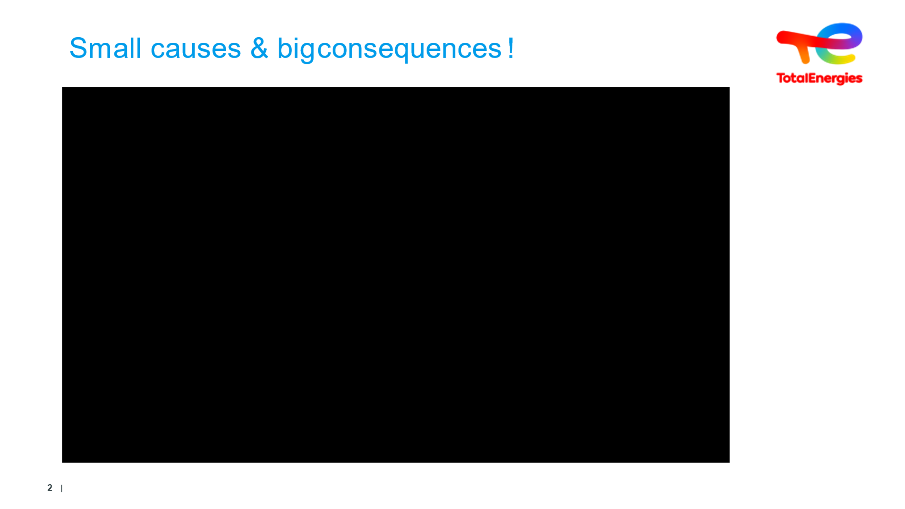  3 min video +  2 min | Getting trainees to guess how the movie unfolds | Participative activity | What is the dreaded HSE incident?  What is common practice in this company?  - Container without closed cap.  - No place to stop.  - “Zero Storage”  - “The line manager is ‘flitty’.”  - “We shout at one another because we’re working super fast”  - Problem gestures and postures - forgetting the palette because we are working -  - “We don’t have time “, no task analysis: in this company tidying up isn’t part of the job,  - “We very often forget them”: Everyone is okay with this shortcoming!  - Everyone acknowledges the risk factor, too: “Best-case scenario, you twist your ankle. Worst-case scenario, you lose it”.  - Fixing anomalies is not part of the job - there have even been accidents “I’ve seen quite a few guys get screwed over that way”  - There has clearly been no experience-based feedback here.  - “It’s a mess. There’s no other way to describe it”. No analysis, no turning back. Nobody is looking beyond the most visible cause.  - “You go past 10 times a day”: This is the probability of occurrence.  - “Everyone does it”: Accepting shortcomings as normal.  - “But the same goes for lots of other things. It’s how things are done.” At this low level of safety culture, dangerous situations exist everywhere and are widely accepted.  - “We’re operating in emergency mode”: A continuous feeling of always being in a hurry  - “I put them under pressure a little”: If management puts pressure on it is understood that management must be exemplary  - “We’re in such a rush we forget small details”: Rushing around - more haste, less speed. The more you’re running late, the more time you should take to get prepared and do it right the first time around.  Problem gestures and postures - forgetting the pallet because the person is working - in this company, tidying and storing away is not considered part of work. Correcting anomalies is not part of the employee’s work - despite the fact that accidents have occurred, clearly nobody has reported this. | Video +
 | 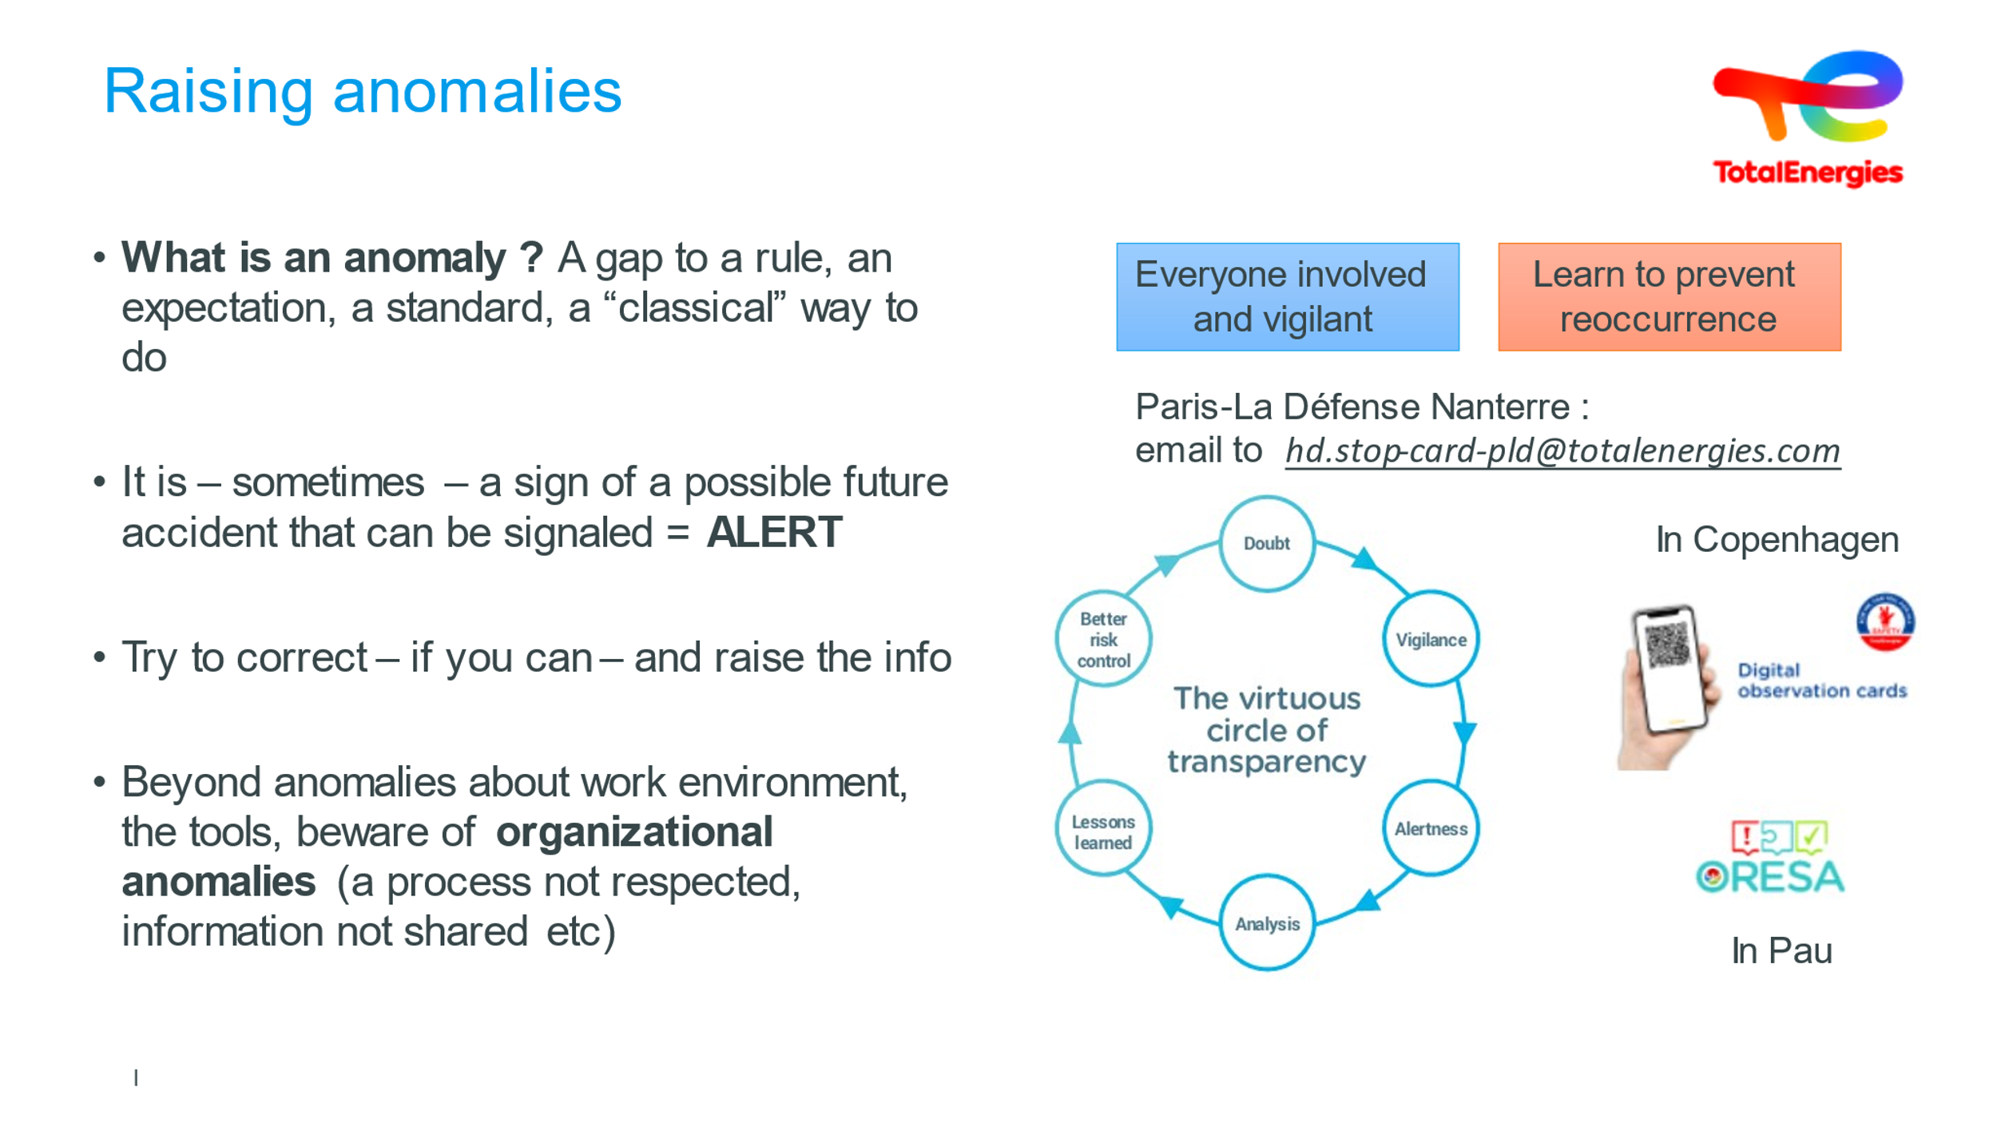  1 min | Raising anomalies | Raising anomalies is avoiding future accidents | Reporting anomalies is everyone's business. There are several ways of doing this, see the examples on the slide :  - Paris La Défense  - Copenhague  - Pau  It's important that each employee is shown the tool in use at his or her site when he or she arrives. | Slide +Oral
 | 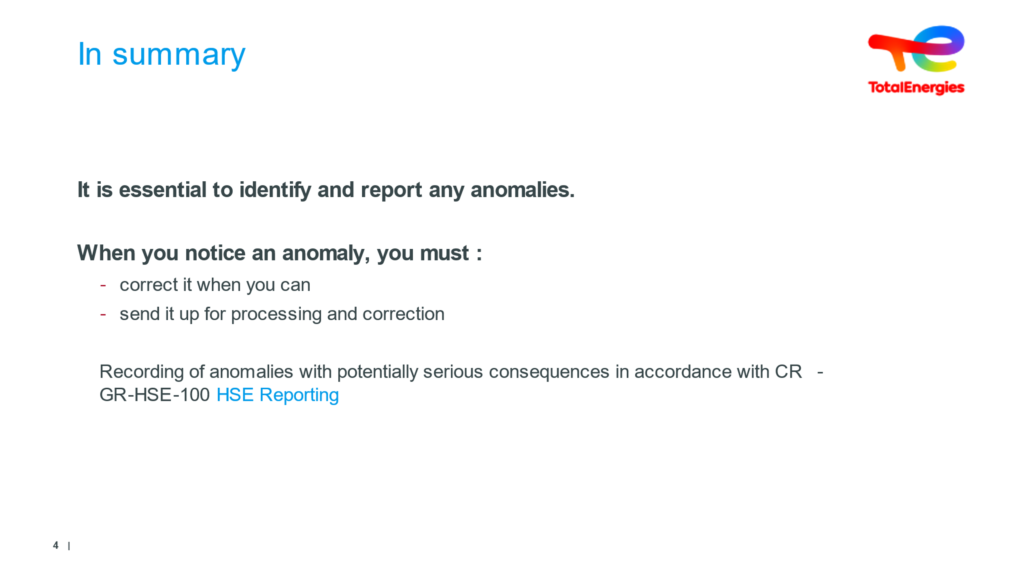  2 minutes | To sum up | Make sure this understood and absorbed | It is essential that anomalies be identified and reported in order to be corrected.  - Because minor incidents or near-misses cannot be identified (or are hard to identify) during risk assessments. For example, the inapplicability of part of a procedure is difficult to identify  - Because they are a very good source of information on structural degradation (technical, human or organizational). For example order and cleanliness  because sooner or later, they will lead to an accident. | Slide + Oral
 | 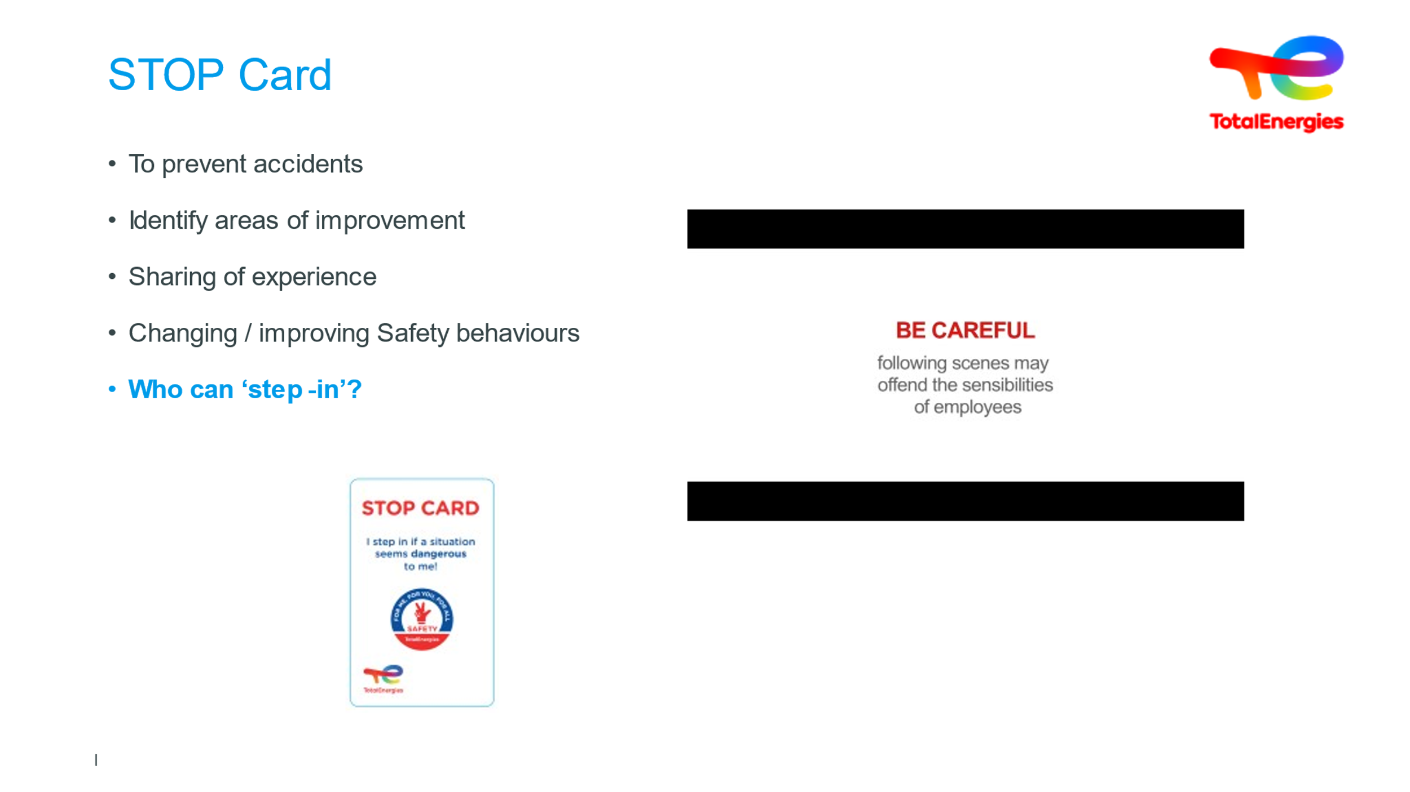  2 min (40s video) | STOP CARD |  | When the STOP CARD is brandished, is the message clear and understood?  Added bonus : The Stop Card, common to all the Company's entities, enables all the company's players, TotalEnergies employees and contracted parties, to act without penalty. | Slide + oral + VIDEO
 | 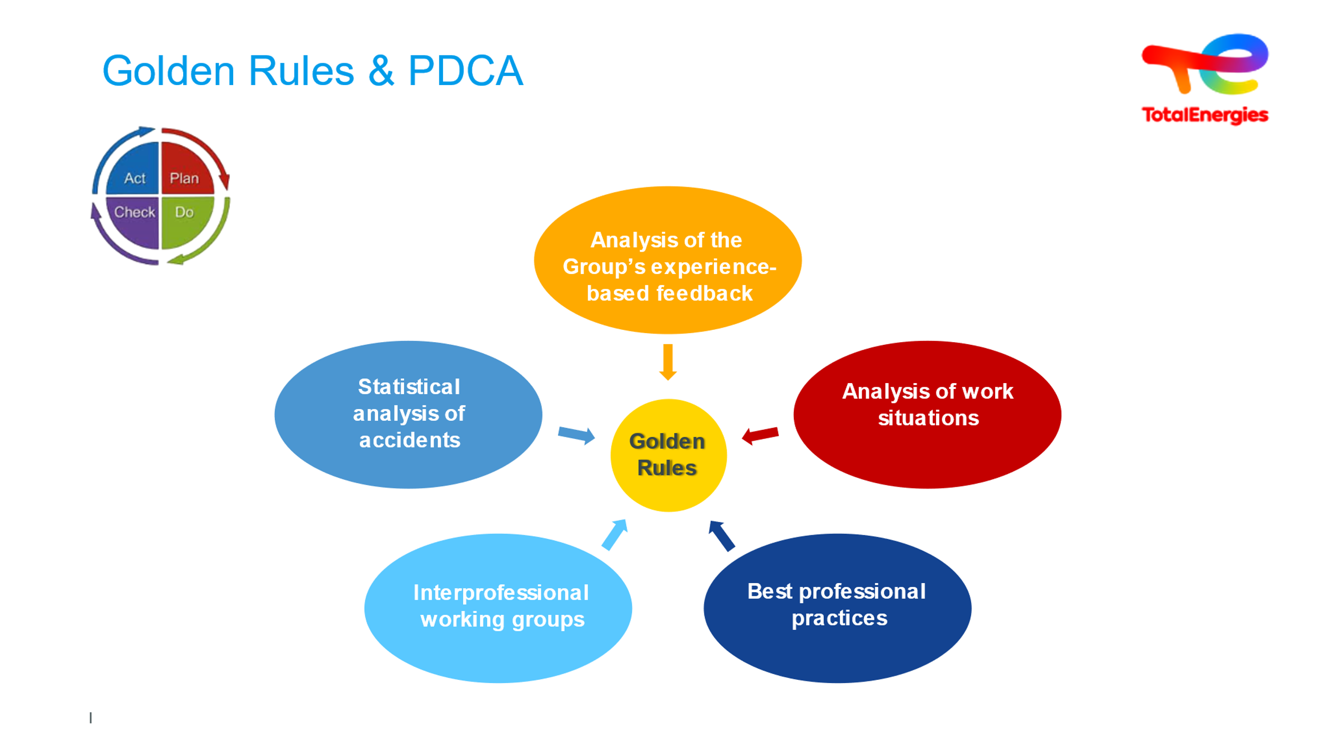  5 min | The Golden Rules & the five expectations, supported by PDCA | Without continuous improvement, we stagnate. We may sometimes even regress. | Ask the question: when you see the Deming wheel - PDCA - what actions will the group take to implement the Deming wheel? After a few ideas, note down if necessary, reformulate if necessary...  Synthesize ideas....  Analysis of work situations.  - Analysis at the workstation / Le Document Unique  - Analysis of EE operating mode: PdP + AT  - Go / No Go  Occupational best practices  - Audit / Safety tour / VCT  - The PdP is drawn up with the active participation of the External Companies.  - Standards  Inter-professional working groups  - TotalEnergies participation in inter-company groups  - GESIP  - UIC / UIP / ...  Statistical analysis of accidentology  - Internal & external accident monitoring  - Inclusion of EE in TotalEnergies indicator  Analysis of feedback  - REX : know how to feed yourself and feed this progress loop  - BARPI's ARIA database  GOLDEN RULES  …is fertile ground for everyone to grow  At the level of the entire company, we carry out a global risk analysis and work with our peers to set up the Golden Rules.  It was teamwork that led to the creation of these Golden Rules. | Slide + Oral
 | 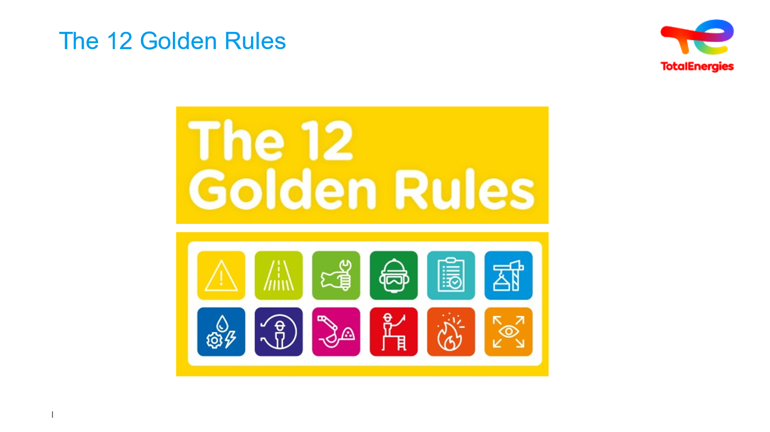  10 minutes | The 12 Golden Rules | The Golden Rules span all actions carried out within your work. | New Golden rules (presented at Global Safety Day on April 29, 2022) are now Formulated as « I… » and limited to instructions for the front line workers.  This allows :  - Aiming for personal commitment.  - Systematic application of the rules through appropriation  - Easier application in the field.  Added bonus : LiZZY includes an e-learning module (each golden rule lasts 8 minutes). | Slide + Oral + Card Game
 | 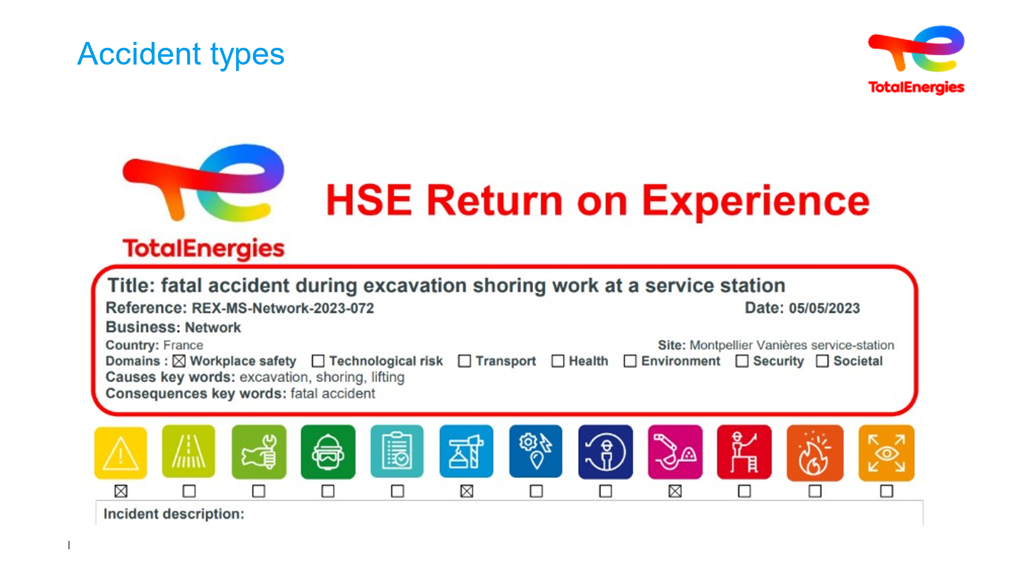  3 min | Accident types | Make it clear that compliance with the Golden Rules can cut back on a great many accidents  (close to 90%) | Ask how many people died in the Company in 2021 (1), 2022 (3) and 2023 (2)?  Mention the 2 fatal accidents in 2023.  Progress requires paying close attention to the circumstances in which fatal accidents occur  In particular, activities during which accidents occur and the root causes of accidents  Ask for the top 5 activities that lead to deaths.  Write down the answers.  - 37% activities above ground  - 21% HGV driving  - 16% lifting  - 11% hot work  - 5% : Dangerous machinery/Worksite machines/Work at sea  Visual with Alert HSE: 1 fatality = 4 non-respected Golden rules !  In addition, when the REX was published, the survey was able to reinforce certain additional discrepancies. | Slide + Oral
 |   4 min | Feedback | Make sure priority levels and variations on the general principles of prevention & the definitions seen above are absorbed.  How experience feedback is handled at TotalEnergies | Start the video, and then ask which of the following applies during each built-in break in the video:  This is a NEAR-MISS  This is an ACCIDENT  This is just a GUIDELINE  This is just a SIGN  This is a RISK REDUCTION  A touch of humor to emphasize the core message  Our falls counter is reporting!  - Detection and reporting  - Qualitative analysis: Incident analysis  - Communications: Safety alert  - Implementation of corrective measures  - Statistical analysis  - Tracking effectiveness of measures  What can they do next at the plant? (Answer: Check all the steps!)  Added extras: The Experience Feedback Rule  CR-GR-HSE-801 HSE Incident Management and Feedback  The Guide  GM-GR-HSE-801 HSE Incident Analysis Guide  The database  Configure your experience feedback parameters to receive alerts | Slide + oral + Videos
 | 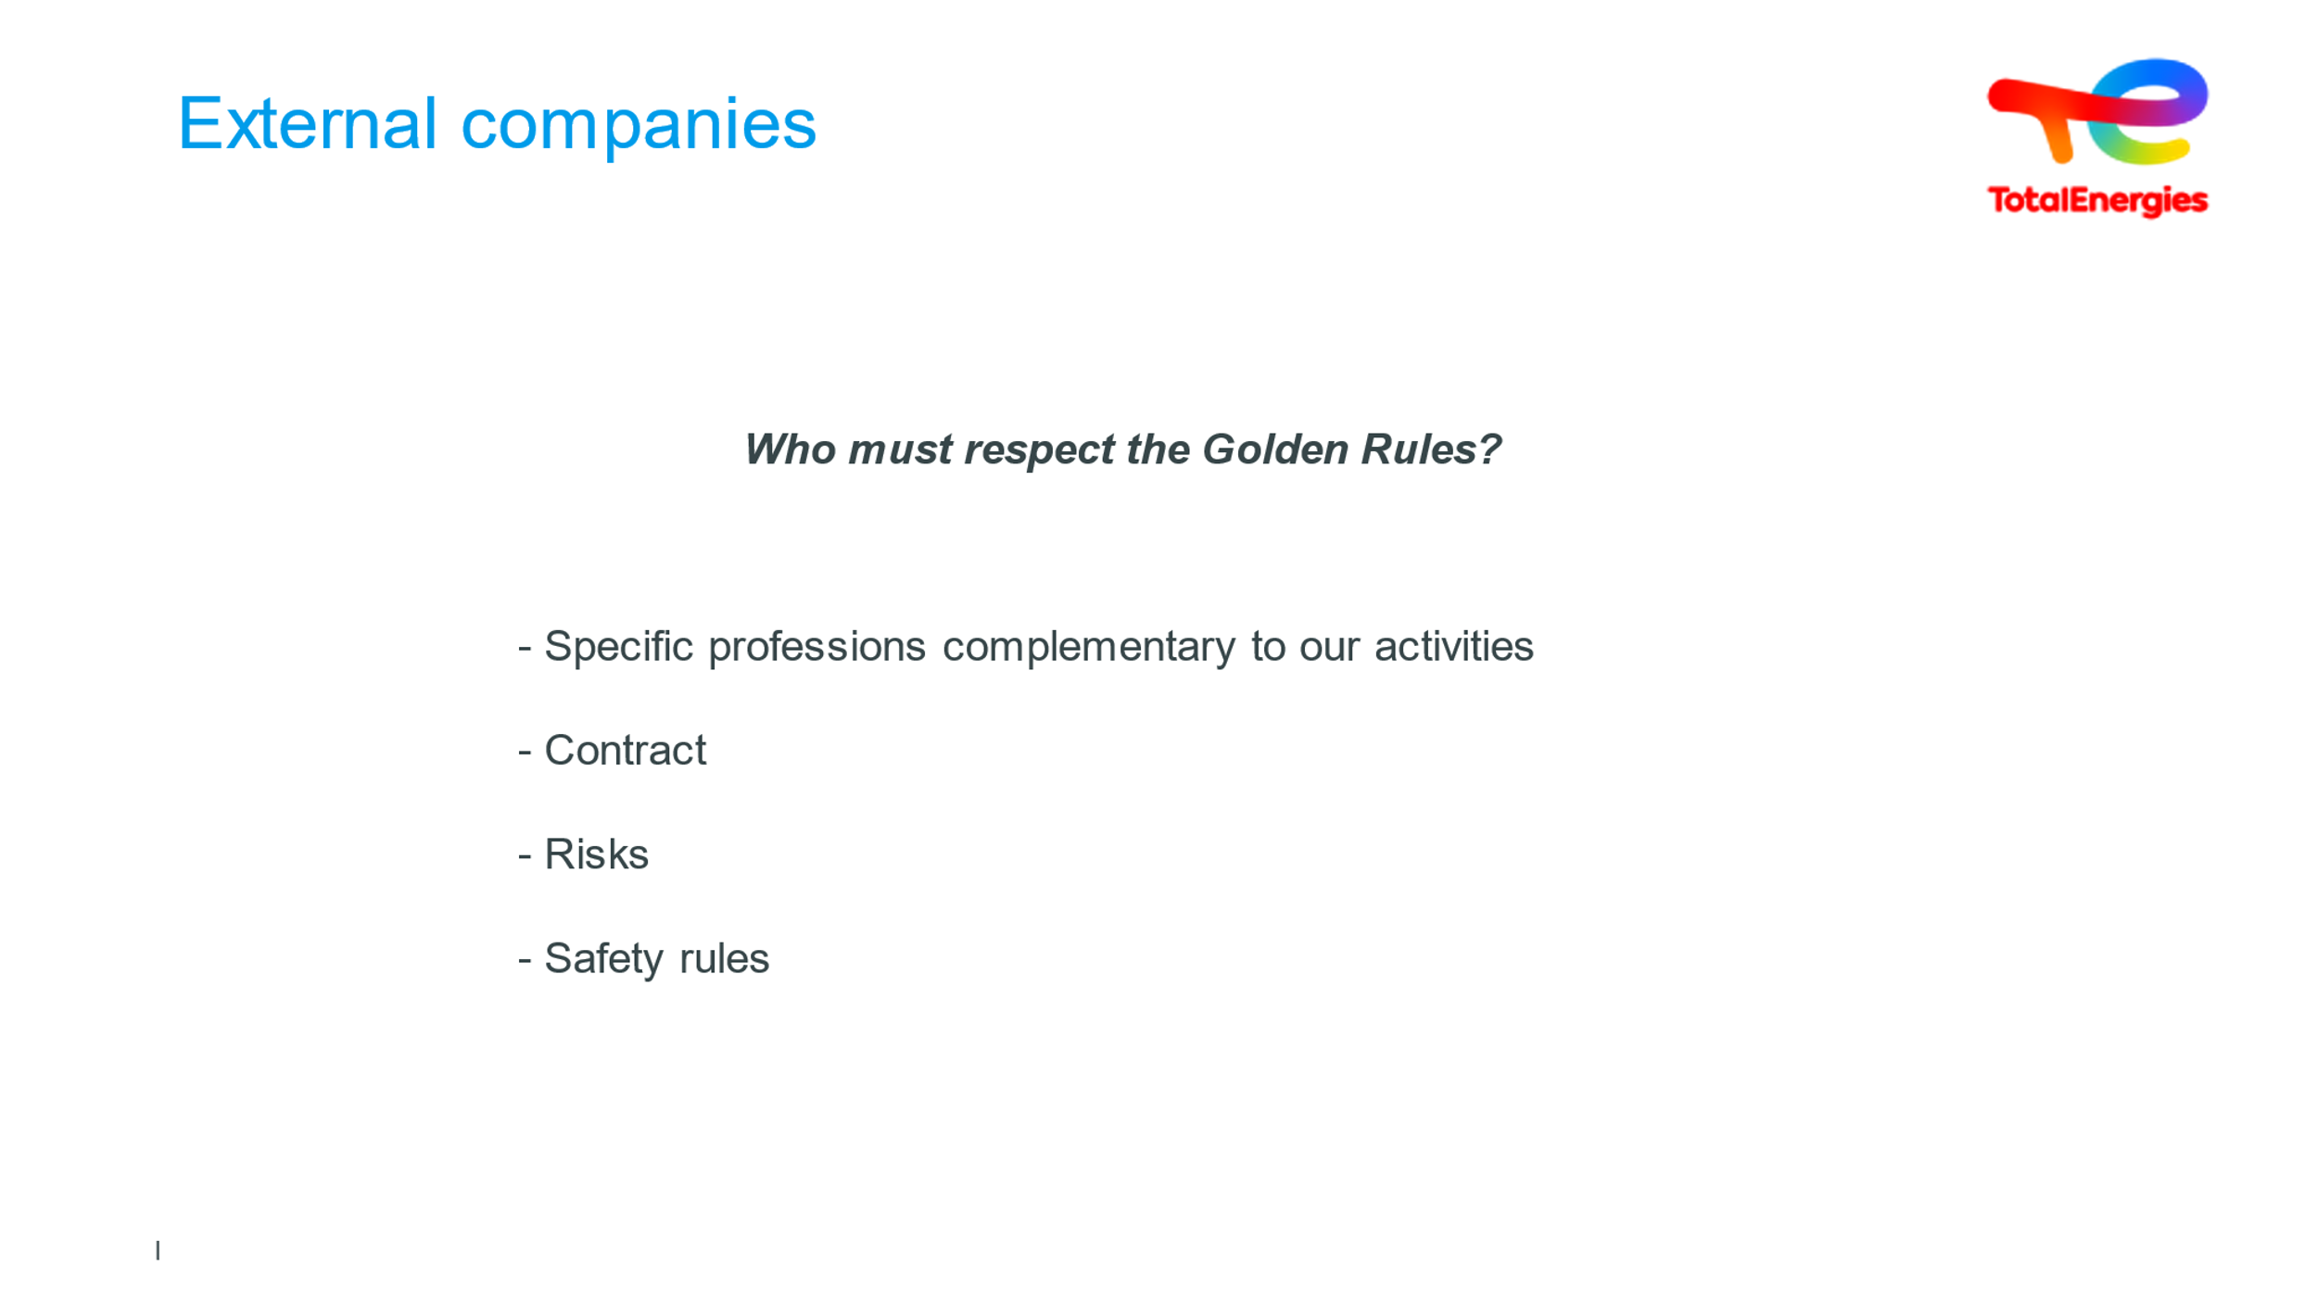  4 min |  | External companies are impacted and contribute to our outcomes! | Read the question and ask for answers.  Browse definitions and examples  External companies have specific roles to play at our sites, with areas of expertise that complement our own  Maintenance  Public  Household  Restaurant  External companies are bound to TotalEnergies via contracts. These contracts state that compliance with our safety measures is required  Staff work on our premises and are exposed to the risks of their trade and the risks of our industry, in which they are not specialists  Staff work in different types of industries that do not all have the same safety rules  External companies are not the same size as TotalEnergies, and may be SMEs  Many accidents are work-related: Works are most often carried out by external companies  Works lead to high-risk situations: working above ground, in confined spaces, excavations, welding, etc.  These risks are combined with those inherent to our activities, workplace safety risks  And with technological risks, too (major fires, flash fire)  Many accidents are work-related  Works are most often carried out by external companies  Works lead to high-risk situations: working above ground, in confined spaces, excavations, welding, etc.  These risks are combined with those inherent to our activities, workplace safety risks  And with technological risks, too (major fires, flash fire) | Slide + Oral
 | 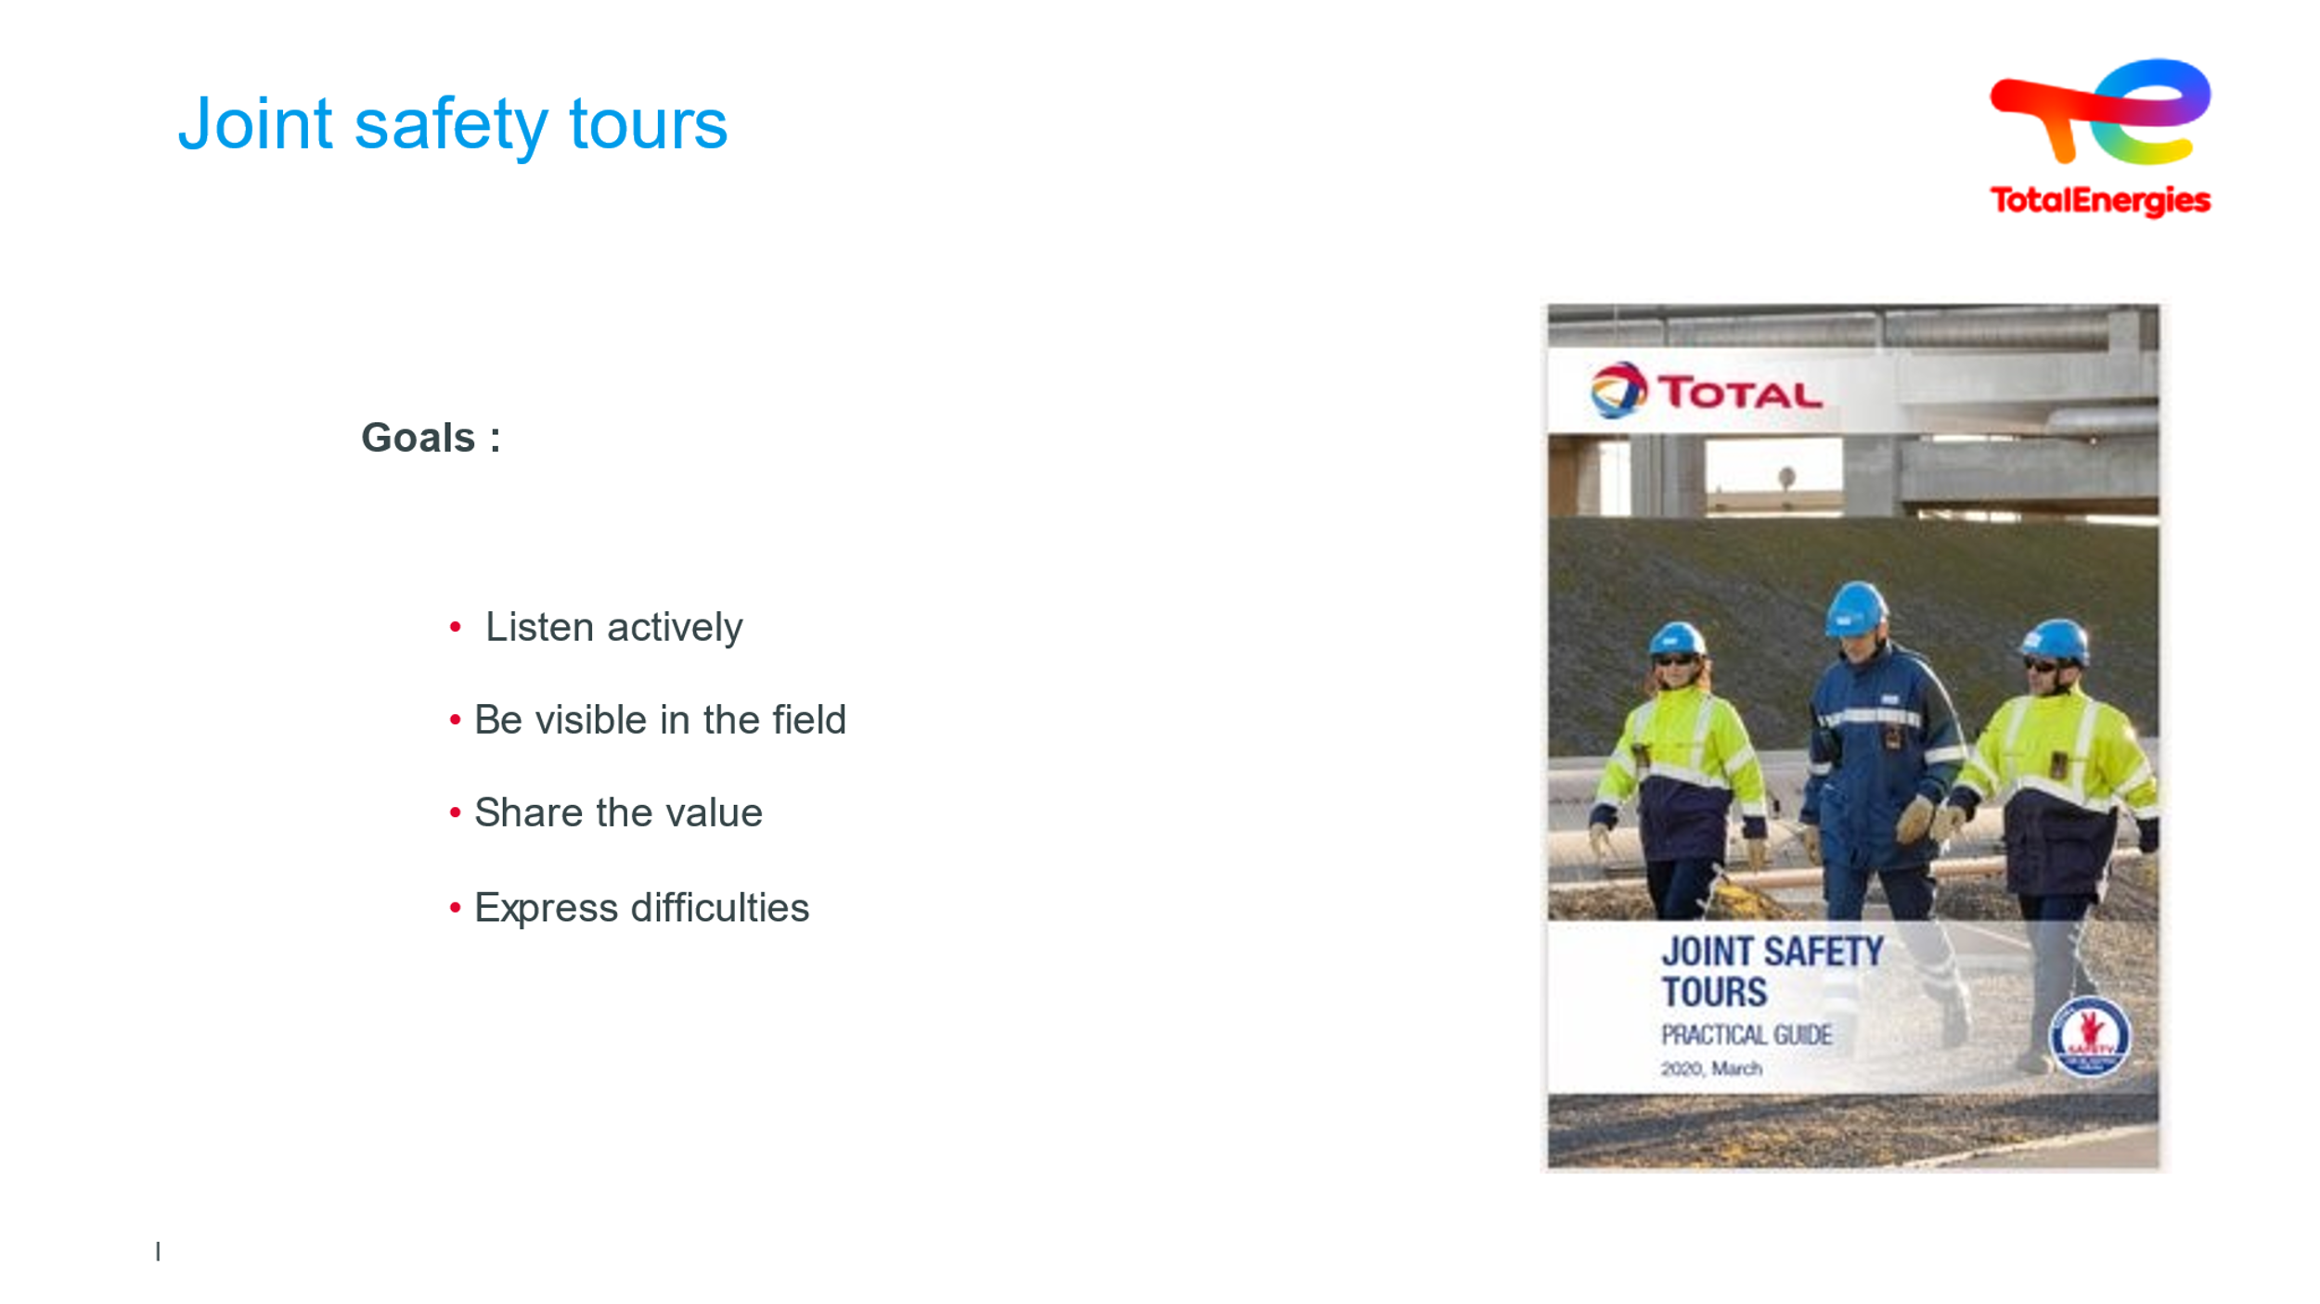  3 minutes | Joint safety rounds | Getting participants to understand the relationship between the company & external companies | Ask how much they know, about expected targets and the benefits of joint safety rounds.  Gather answers, drawing on those who are familiar with the practice, or have participated in one before.  Then sum up...  Goals:  - Enable active listening  - Listen to external companies who know more about their area of expertise than we do  - Be visible on the ground to demonstrate that safety is a value for us  - Ensure TotalEnergies and its partner companies share in the process  - Allow staff on the ground to express difficulties | Slide + Oral
 | 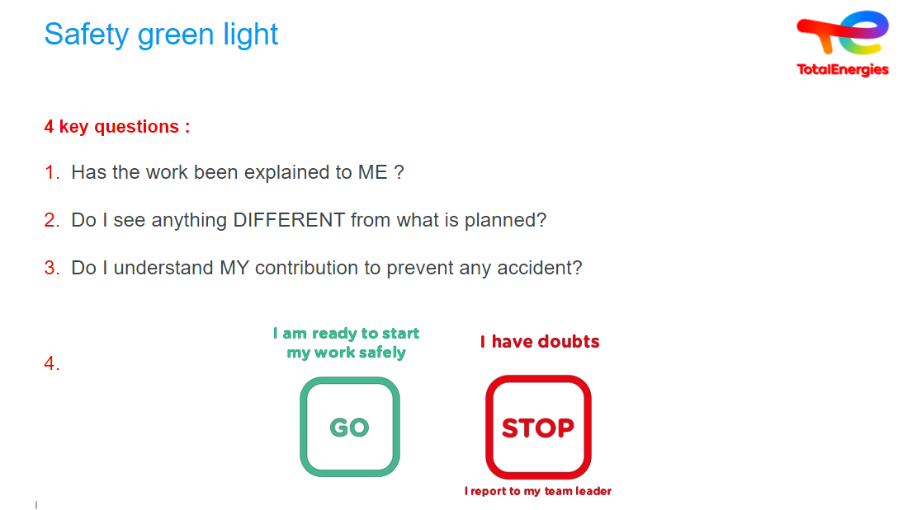  2 minutes | Safety green light | One last check...  Take a critical view before you start | Despite all the risk analyzes and barrier measures put in place, there is still the possibility that when work starts, a measure isn’t in place, or a condition has changed.  Goals:  - Promote awareness of deadly hazards through a final verification drawing on open questions  - Take a step back when doubt emerges surrounding individual or collective ability to perform work safely  - Allow for a final decision: GO/STOP  Where?  - At the intervention site  - Each time work starts  - People carrying out the work  - TotalEnergies and external companies  A real-life example :  The example of the pedestrian about to cross a crosswalk. The rule is quite clear: even if there is a crosswalk, even if drivers must stop when someone is about to cross, the pedestrian must take a few seconds to think just before crossing, looking from left to right, before committing himself. This is the very spirit of Safety Green Light : a quick exchange between the parties involved, a step back, just before starting the task, to make sure that everything is in order before setting off. | Slide + Oral
 | 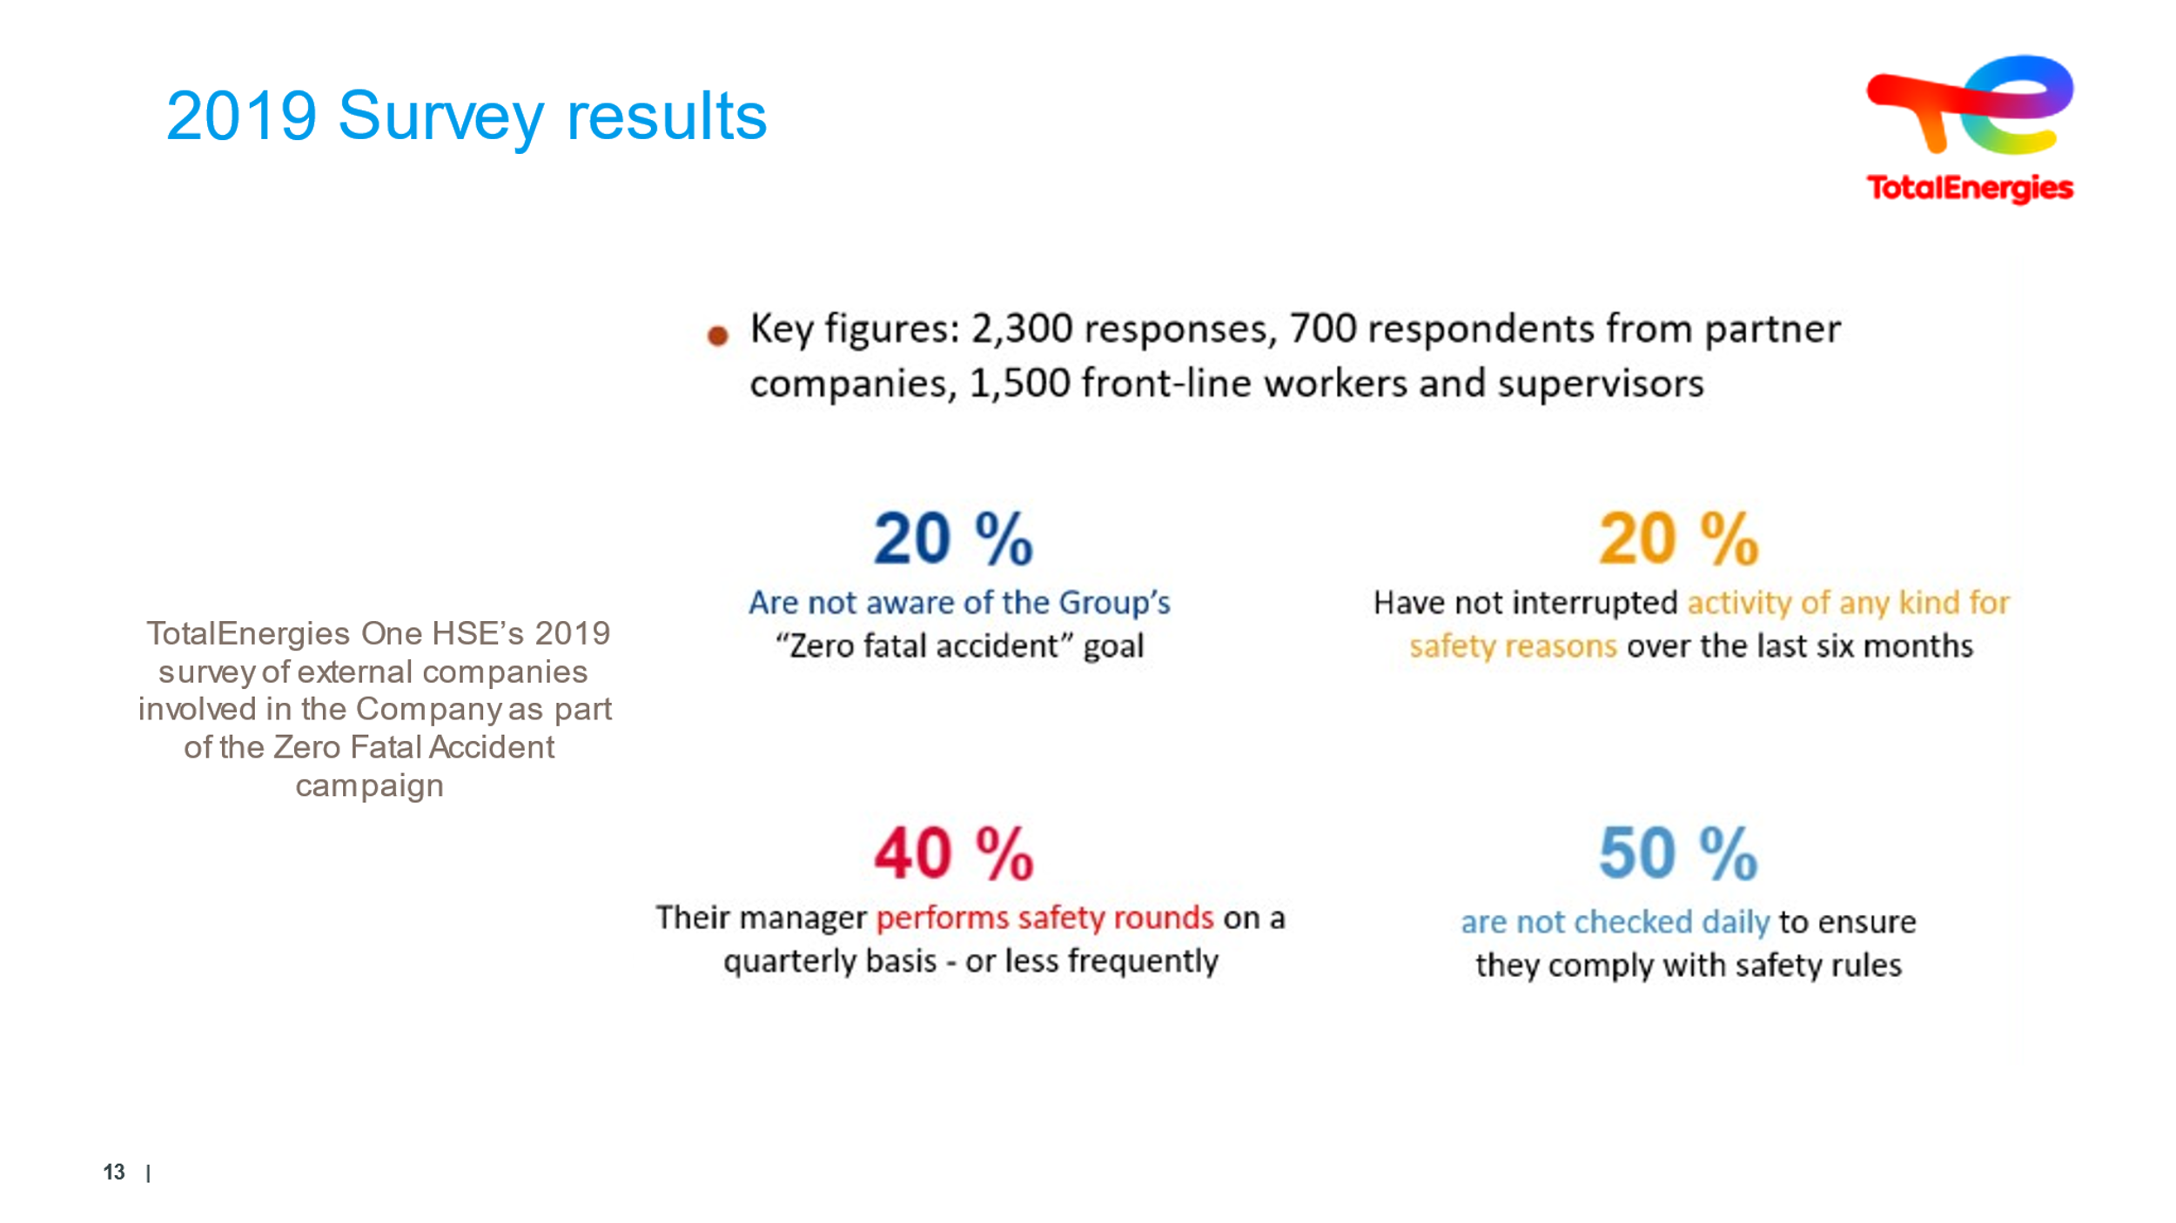  5 minutes | Survey highlights |  | A handful of hard-hitting key figures to share with trainees.  Inform trainees that these results are the outcomes of a working group:  - A working group was set up in 2019 in a continuation of the 2015 working group with a view to bolstering the ZERO FATAL ACCIDENT plans  - This group enabled us to gather feedback from external companies with respect to the quality of TotalEnergies’ relations with its subcontractors  - One conclusion to emerge was that the partnerships we build aren’t solid enough.  - The Joint Safety Tour is one of the measures taken  The following is a list of actions carried out on a DAILY basis with external companies  - Listening to any potential HSE difficulties  - Collecting proposed suggestions  - Leading by example in HSE: PPE, compliance, etc.  - Being familiar with the contracts and what is expected in terms of HSE  - Recognizing performance (positive and negative)  - Common audits | Slide + Oral
 | 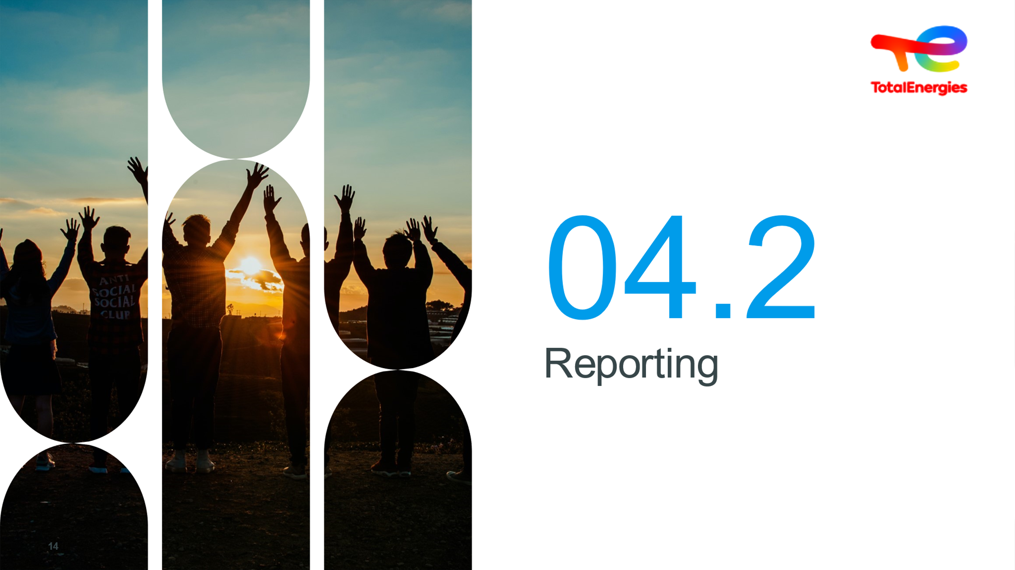 | Reporting | Understanding reporting | Project the slide and read the title without further ado | Slide + Oral
 | 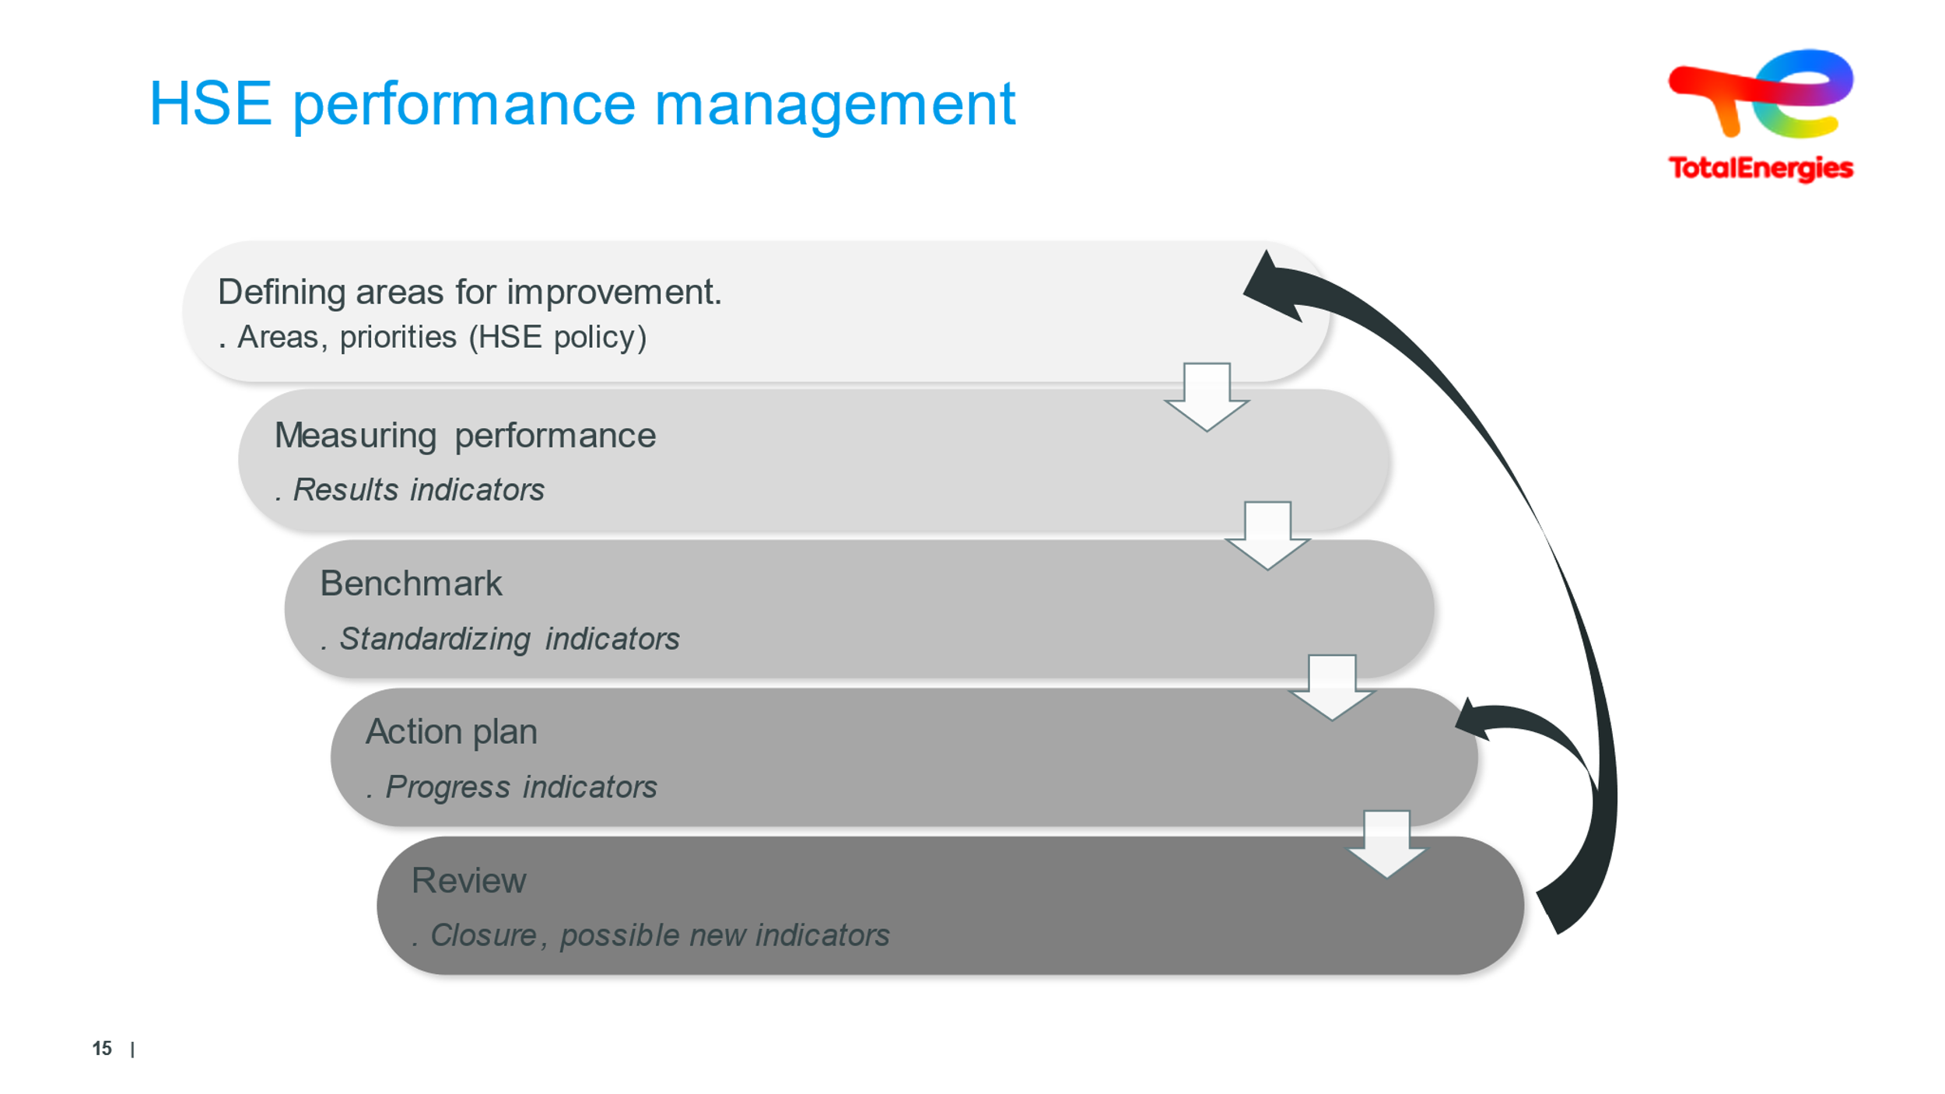  7 minutes | HSE Performance Management | Understanding how to manage HSE performance | “Areas of progress” to be defined in line with reviews, audits, etc.  “Measuring performance” for results in order to tweak and refocus  Compare our figures to those of leaders/benchmark  Measuring how effective the action plan is  Review, check action plan effectiveness and adjust it  - The two arrows are reminiscent of the Deming circle: this lies at the heart of the idea of continuous improvement  Added extras: Learning organization:  Safety Lessons and Progress (experience feedback)  Willingness to monitor progress and measure the effectiveness of policies and measures in place: Figures and statistics (All progress can be measured)  - Regulatory requirements: accident reporting, incident frequency rate measurements  - A CR-GR-HSE-100 Company Rule | Slide + Oral
 | 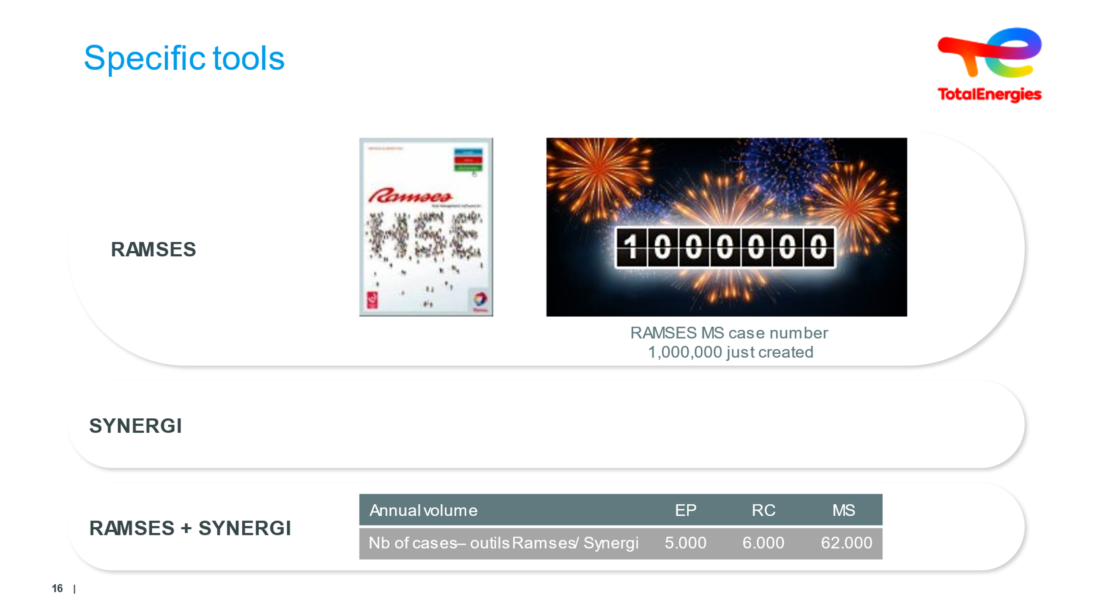  5 minutes | RAMSES/SYNERGI | Becoming familiar with these two tools | RAMSES means Reporting & Management Support, Safety, Environment & Health  This is used to report incidents, accidents, events (near-misses) [Reporting & Management Support, Safety, Environment & Health]  We're counting on you to contribute to reporting incidents - in order to flag them up.  SYNERGI, a tool that allows you to:  - Create:  Incident reports (RAMSES cases)  Statistical reports (digital data collection, case counting)  - Manage incidents and action plans  - Share cases  The more elements flagged (the more reporting done), the closer we will be to fully controlling our risks.  When volumes become significant, the figures given are as closest to reality as possible. | Slide + Oral
 | 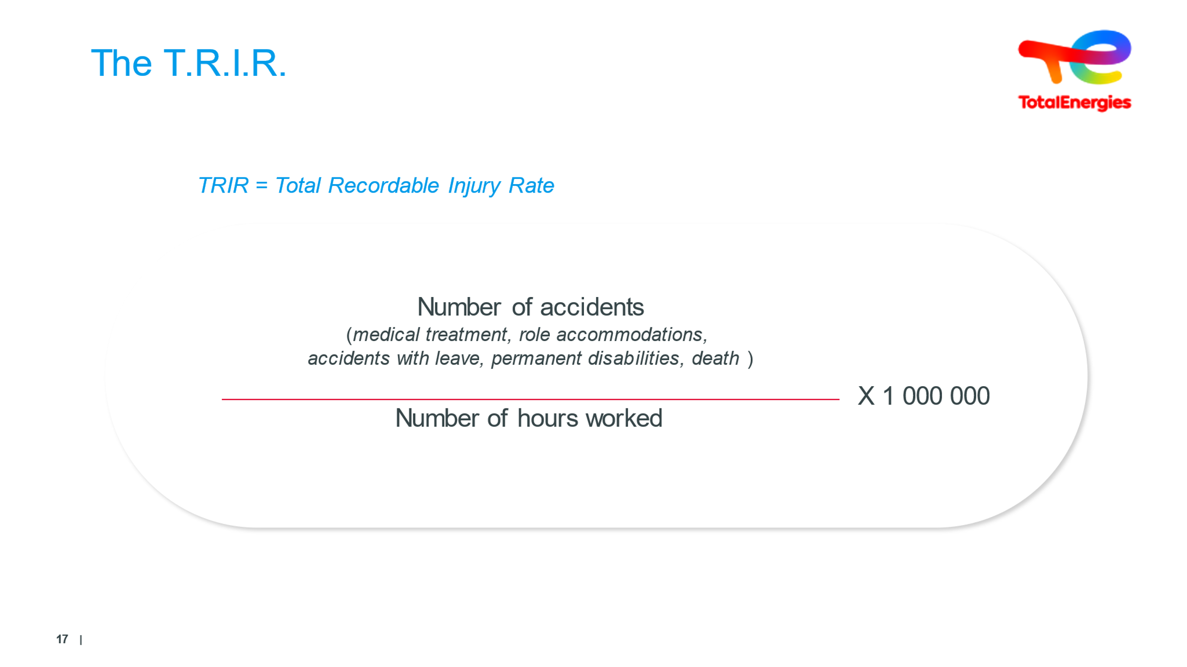  3 minutes | TRIR  (Total Recordable Injury Rate)  Incident rates declared to CARSAT  (Pension & Accident Insurance Fund) | Getting to grips with the definition of TRIR | Calculated for TotalEnergies employees and contractors  It includes :  - Medical treatment (accidents requiring further examination after a visit to the infirmary)  Classified as Level 2 MODERATE  MT: Medical Treatment  - Adapted workstations (accidents preventing an employee from working at his or her current job, but allowing him or her to temporarily occupy another position after receiving medical advice)  Classified as Level 2 MODERE  in RWC : Restricted Work Case  - Lost-time accidents (accidents preventing the employee from holding a position within the company)  Rated Level 3: SERIOUS  LTI : Lost time injury  - Fatalities  Classified Level 4: VERY SERIOUS (1 internal fatality)  Classified Level 4: CATRASTROPHIC (several internal fatalities + 1 external fatality or several injured)  Classified Level 5: DESASTEROUS (several internal fatalities and several external fatalities)  In FAT : Fatality  Excluded: first aid, occupational diseases | Slide + Oral
 | 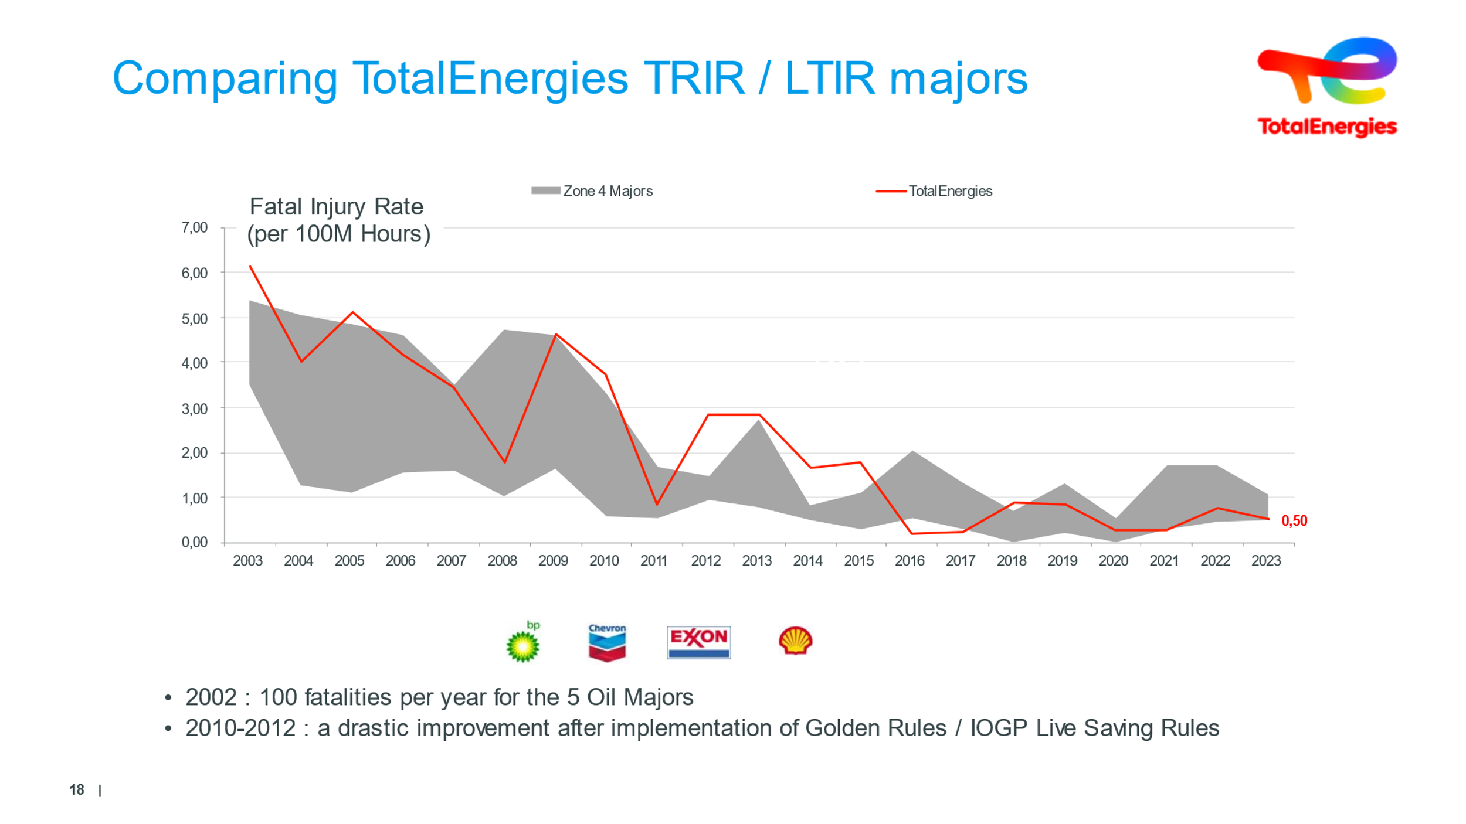  5 minutes | Show how TOTALENERGIES’ TRIR has changed for the better | A huge improvement indeed, but it’s a real struggle to maintain it.  Nothing can ever be taken for granted! | Considering leading companies’ rates are visible and have been evolving in this way since 2005, how does TotalEnergies’ TRIR measure up (Above (meaning not as good/At the same level/Below (meaning better)?  After a quick chat...  We were far from coming out tops, and we put in a lot of hard work to get where we are. Now that we’re committed to better energy, we want to become a leading name in safety  Careful : it only takes a handful of accidents to impact on the TRIR.  TRIR is a globally-recognized standard in the oil industry  It’s an indicator that was established in the United States (OSHA). There are therefore texts that define the accidents to be taken into account (OSHA, IOGP) | Slide + Oral
 | 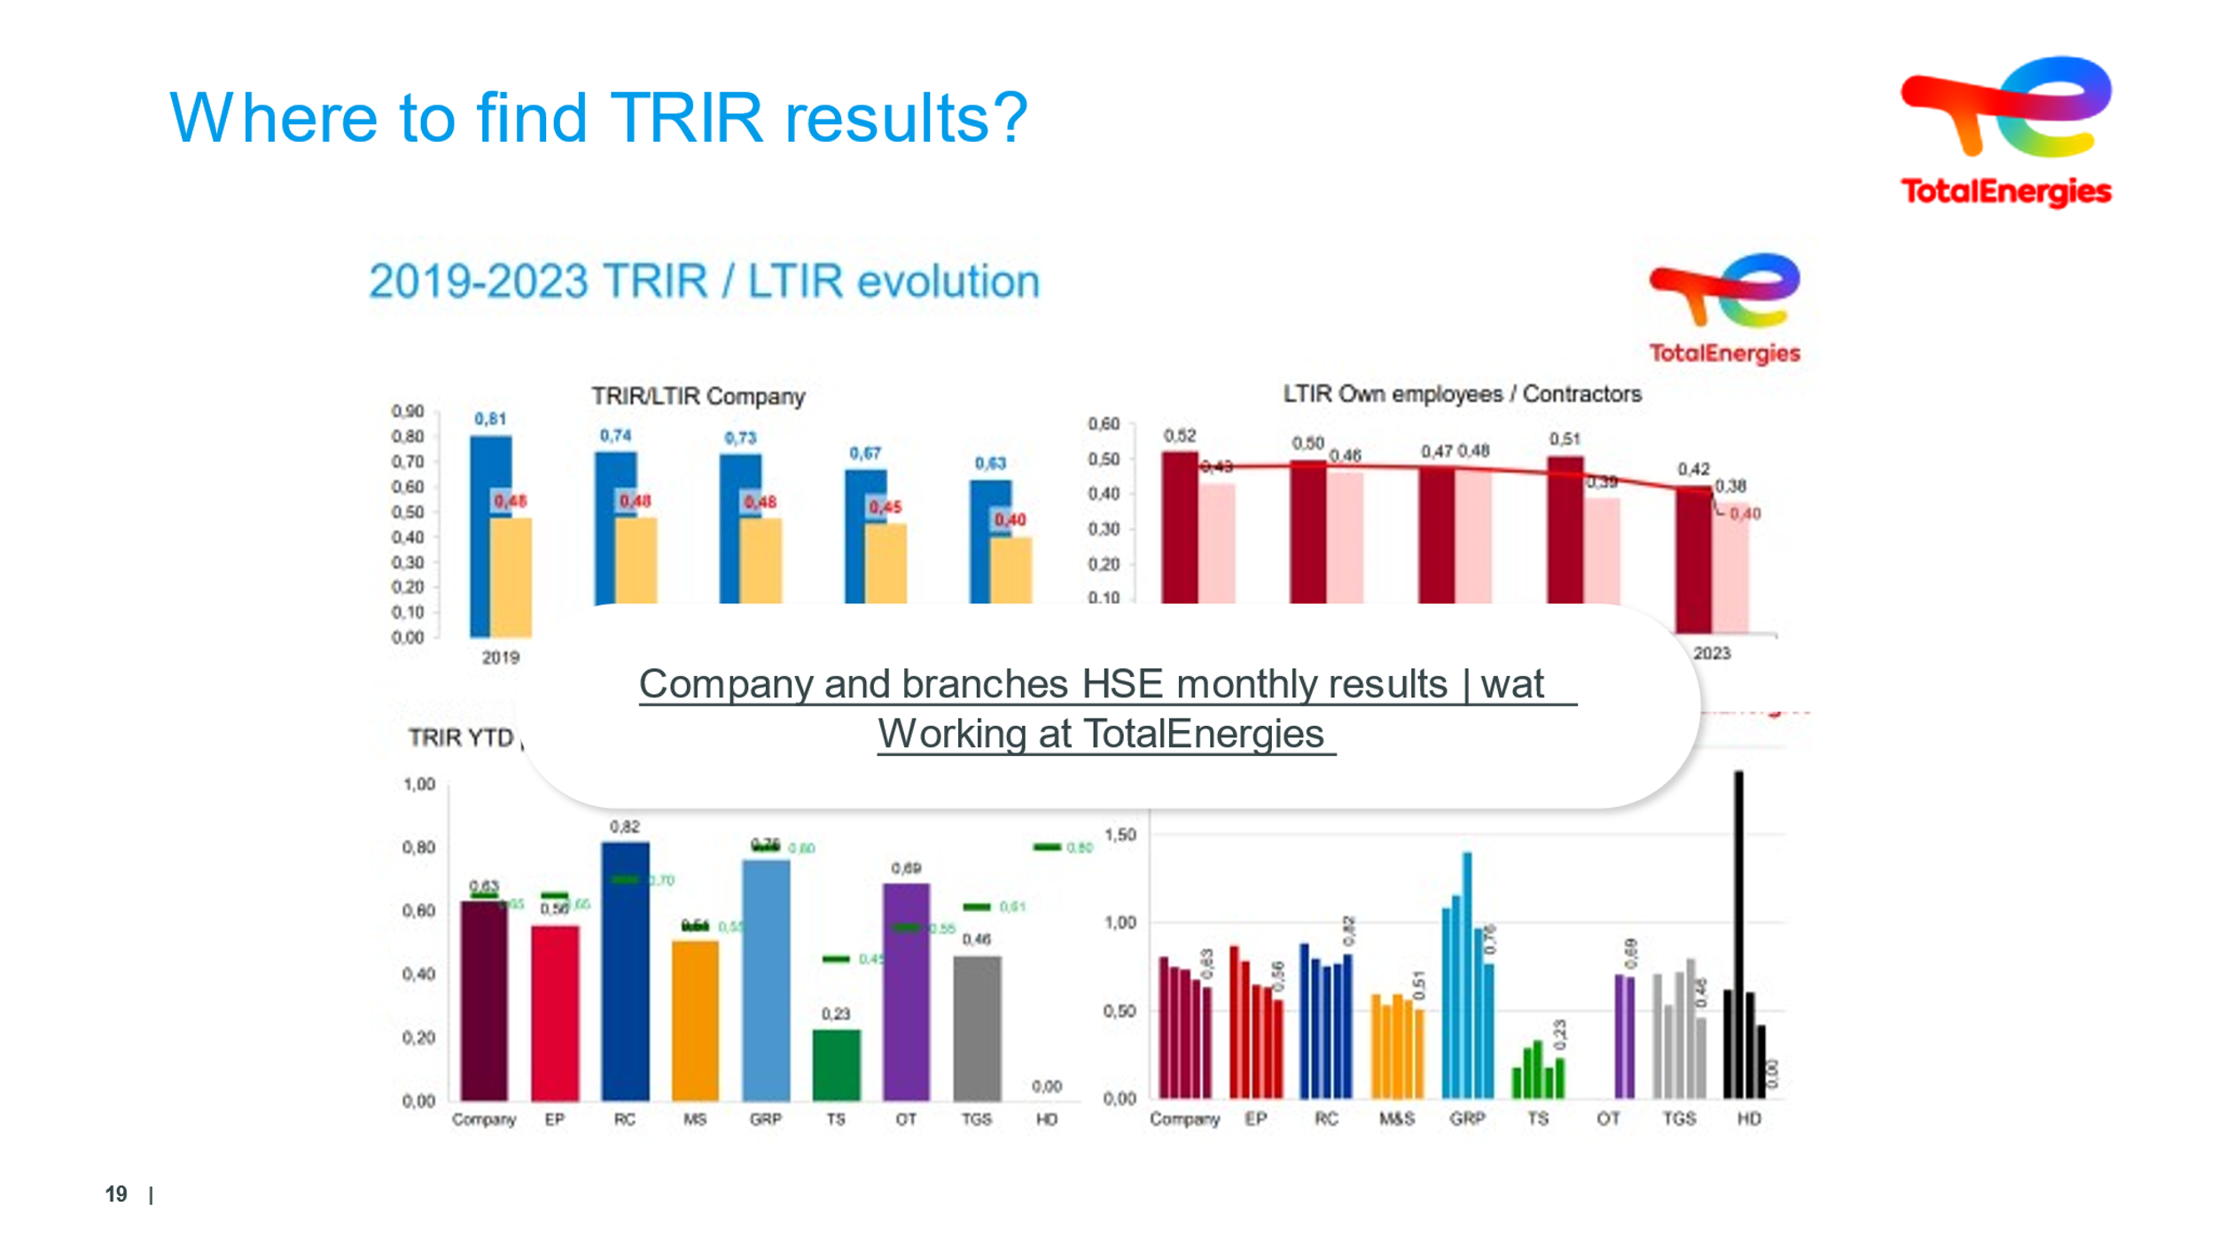  5 minutes | Know how to access TRIR via WAT | Where can you find the safety results? | The facilitator pulls up the latest TRIR results, by clicking/sharing the link located in the middle of the four boards  They provide a commentary on the figures and can give details of the accidents (details provided on the website)  Added extras: https://wat.totalenergies.com/fr-en/job/metier-h3seq/resultats-mensuels-hse-compagnie-et-branches?no_pref=1 | Slide + Oral + WAT
 | 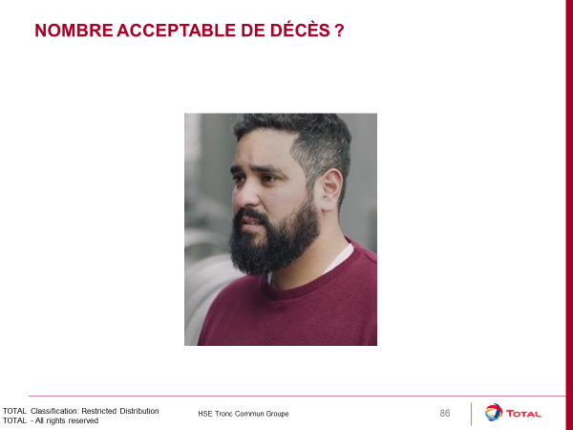 3 minutes | Even a single death is unacceptable | ‘Just a few’ deaths: too few too many | How many road accident deaths are acceptable?  Launch the video...  Added extras: Number of road deaths per year in France:  In 1960: 10,000 deaths  In 2016: 3,400 deaths  In 2020: 2,780 deaths | Video
 | 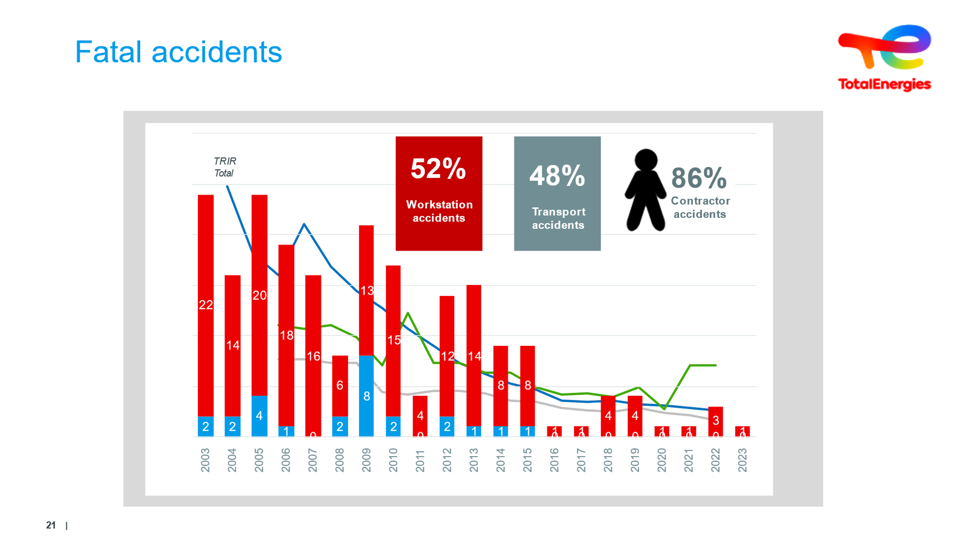  5 min | 96 deaths between  2009 & 2020 | Discover the causes of four deaths in 2019 | Above all, note the slope since 2009...  We’re heading in the right direction.  But you can see that between 2016 & 2020, we jumped from one to four annual deaths (for different events and not a single event causing four deaths). These results are therefore quite volatile.  But having just one death per year, although unacceptable in itself, must comfort us all in the fact that the target of 0 deaths is therefore realistic, achievable, and has actually been achieved since August of this year, over 12 rolling months...  It should be understood that staff from external companies are the most impacted, accounting for 84% of deaths....  This is one of the reasons why our providers must adhere to upholding safety as a value, and to our HSE approach. Ultimately, all EC staff must know and follow our golden rules (remember: 86% of accidents could have been avoided had the golden rules been followed!)  Finally, workstation and transport accidents cause these deaths...  This leads us to two conclusions:  - Control technological risks... while remaining vigilant. Tech. Do not lose sight of technological risks, which remain highly present in the HIPOs. This means they must not be neglected as the stakes are huge.  Workstation accidents are partly the ones we encounter in everyday life outside of work, partly when we tinker at home as well. So if we can make individual progress in the workplace, everyone will benefit - including in a family context | Slide + Oral
 | 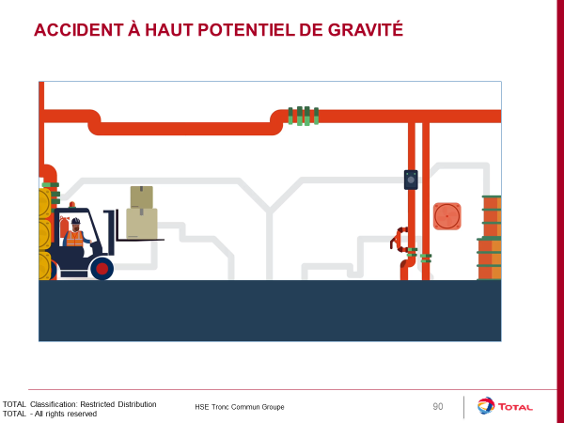  3 min  1 min | Situations with a high seriousness potential | HIPO | Play the animated movie  Synthesis: Common point between industrial and workplace fatalities: high seriousness potential - commonplace non-compliance | Slide + Oral + Video
 | 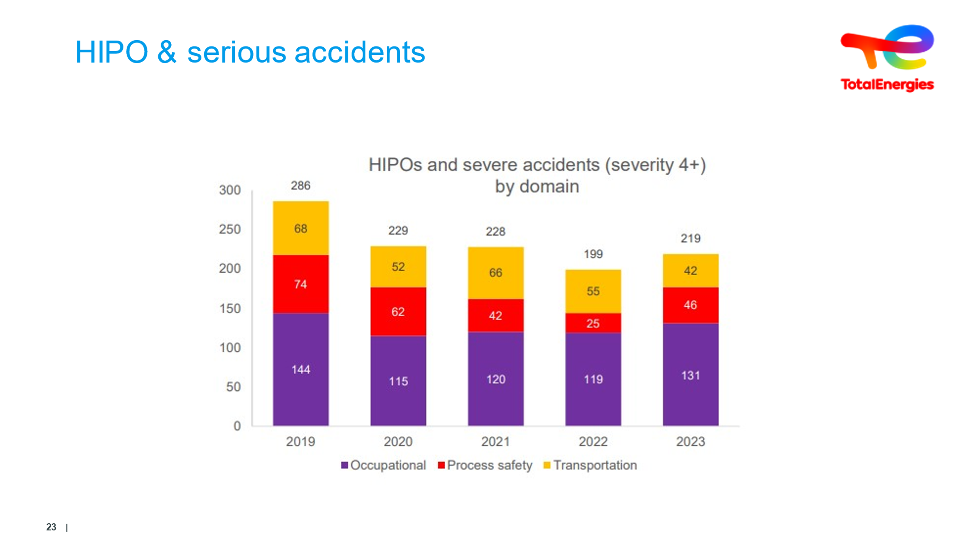  6 minutes | HIPO & serious accidents | What causes HIPO incidents? | The number of severe or high-potential events is up slightly compared to 2022.  - The share of events linked to technological risk has particularly increased, returning to the 2021 level.  - The number of workplace-related events is also increasing.  - The number of transport events is decreasing, which is in line with other transport indicators. | Slide + Oral
 | 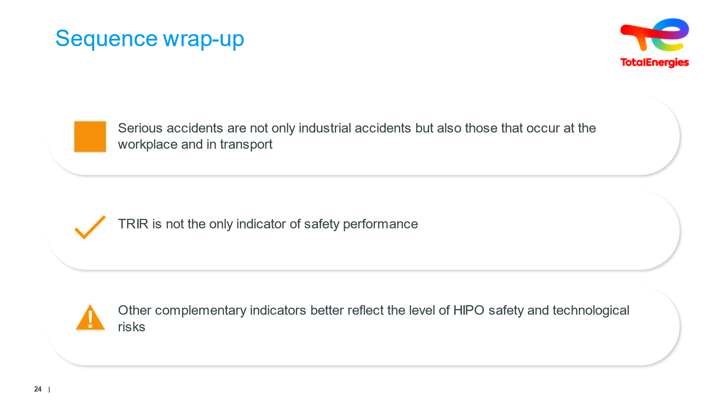  3 minutes | Conclusion | Dispelling misconceptions! | At the start of yesterday, we looked at technological accidents. This morning, we focused on human accidents... And we’ve covered what the developments in the number of accidents and deaths have been, too.  TRIR and HIPO...  Tous les événements HSE sont enregistrés et traités  Learning Organization:  Safety Lessons and Progress (experience feedback)  Willingness to monitor progress and measure the effectiveness of policies and measures in place:  Figures and statistics (All progress can be measured)  Added extras: Why do we report?  To improve!  To measure progress,  To progress!  Regulatory obligation to measure  Regulatory obligation: accident reporting, frequency rate measurement.  A CR-GR-HSE-100 Group Rule | Slide + Oral
 | 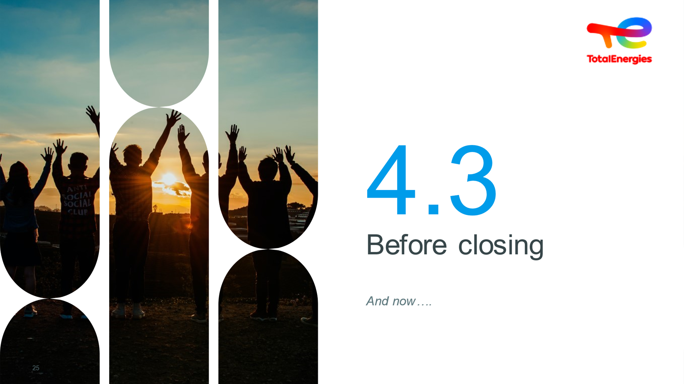  1 min |  |  | Project the slide and read the title without further ado | Slide
 | 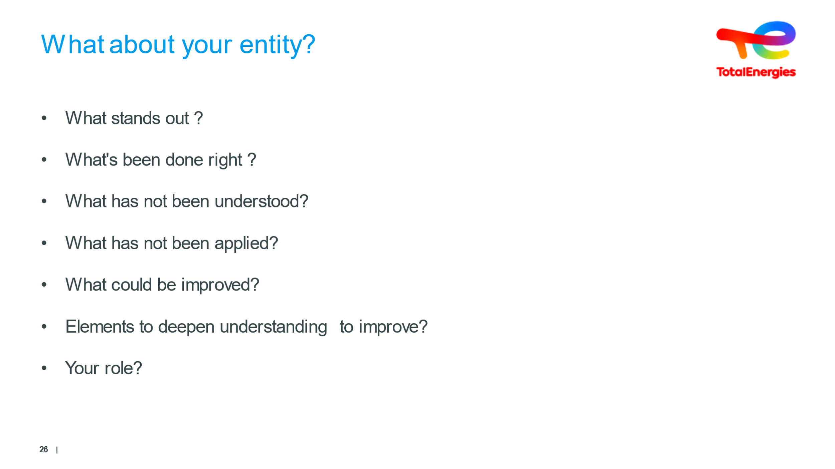  5 min | What about your entity? |  | Ask the questions  Then the trainees reflect  After answers from the employees, conclusion | Video
 | 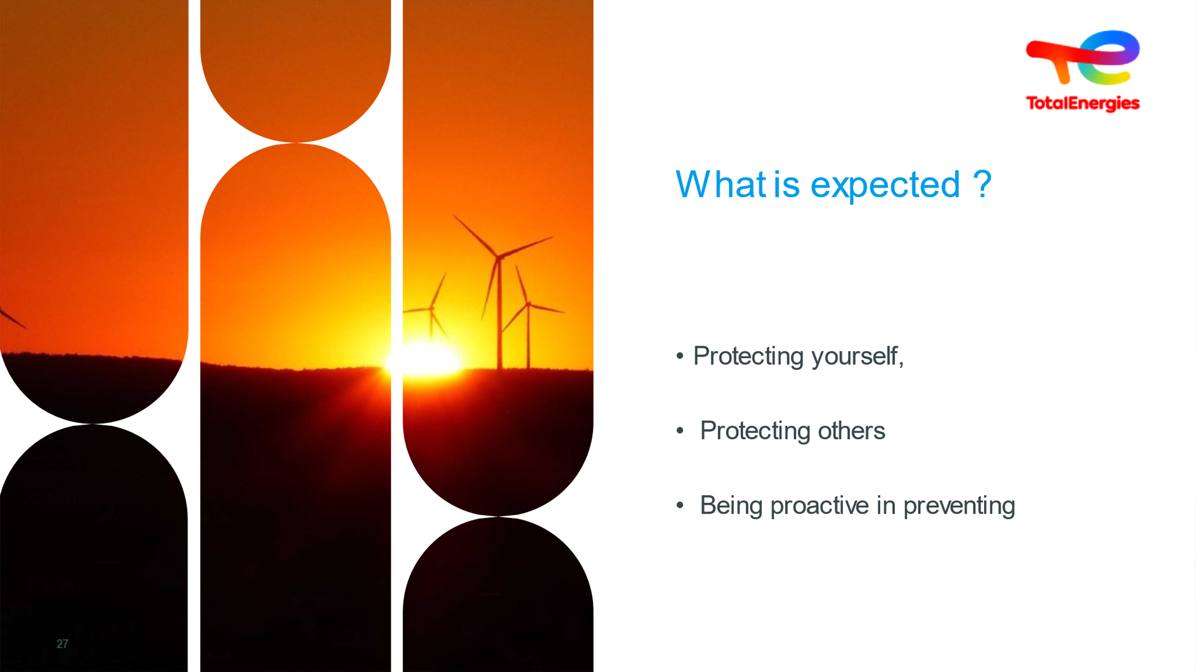  3 minutes | Protecting yourself,  Protecting others  Being proactive in preventing | What we expect of you | In terms of protecting yourself  - Look into evacuation and emergency procedures  - Find out which emergency number to call  - Wear mandatory personal protective equipment  - Apply the Safety rules you are told to follow.  - Assess the risks before taking action  In terms of protecting others  - Stay alert and aware, dare to intervene  - Sign up for Occupational Rescue Worker training  - Prepare before interventions (familiarize yourself with the rules, knowledge, experience feedback, people involved before starting work).  Being proactive in preventing  - Reporting anomalies  - Studying experience feedback  - Knowing and complying with rules and guidelines  Pitfalls to avoid  - Allowing non-compliance to become commonplace: ‘we’ve always done it this way’!  You may be tempted to...  - Not declare an accident  - Minimize potential consequences | Slide + Oral
 | 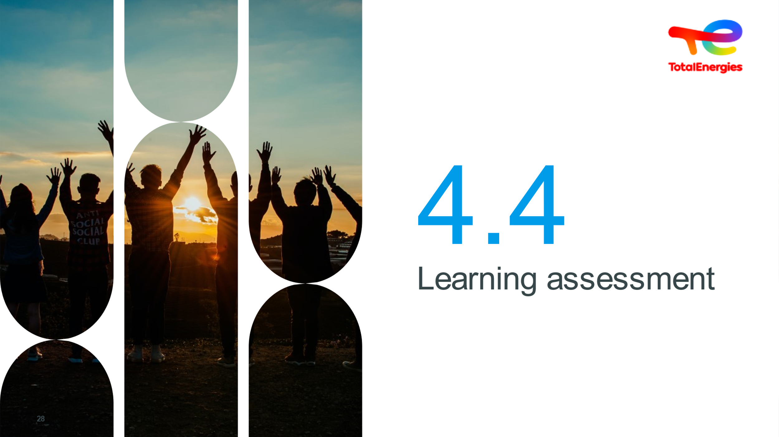  1 min |  | Learning assessment | Optional quiz to be carried out at the host's discretion. | Slide + Oral + Tableau
 | 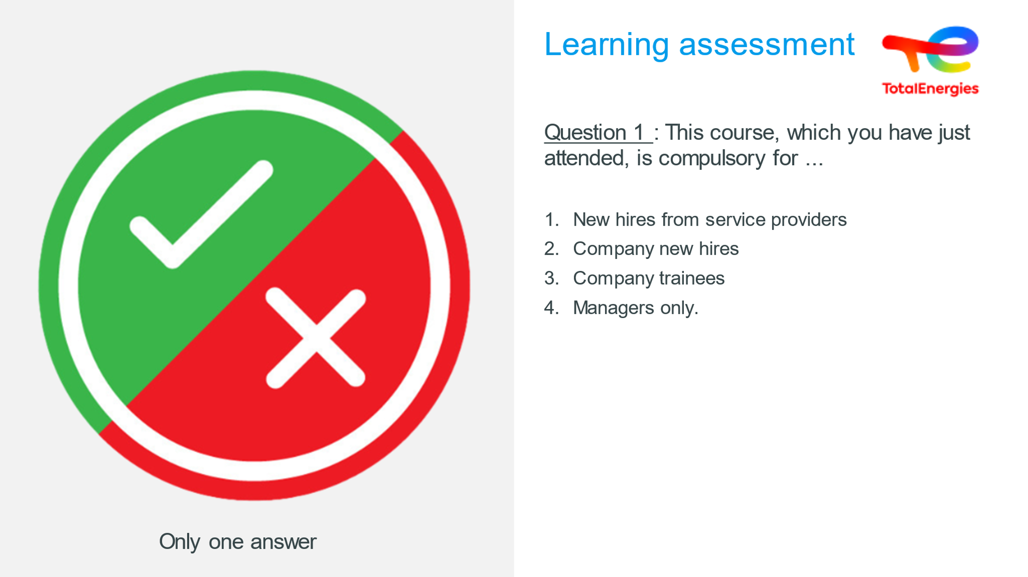
 | 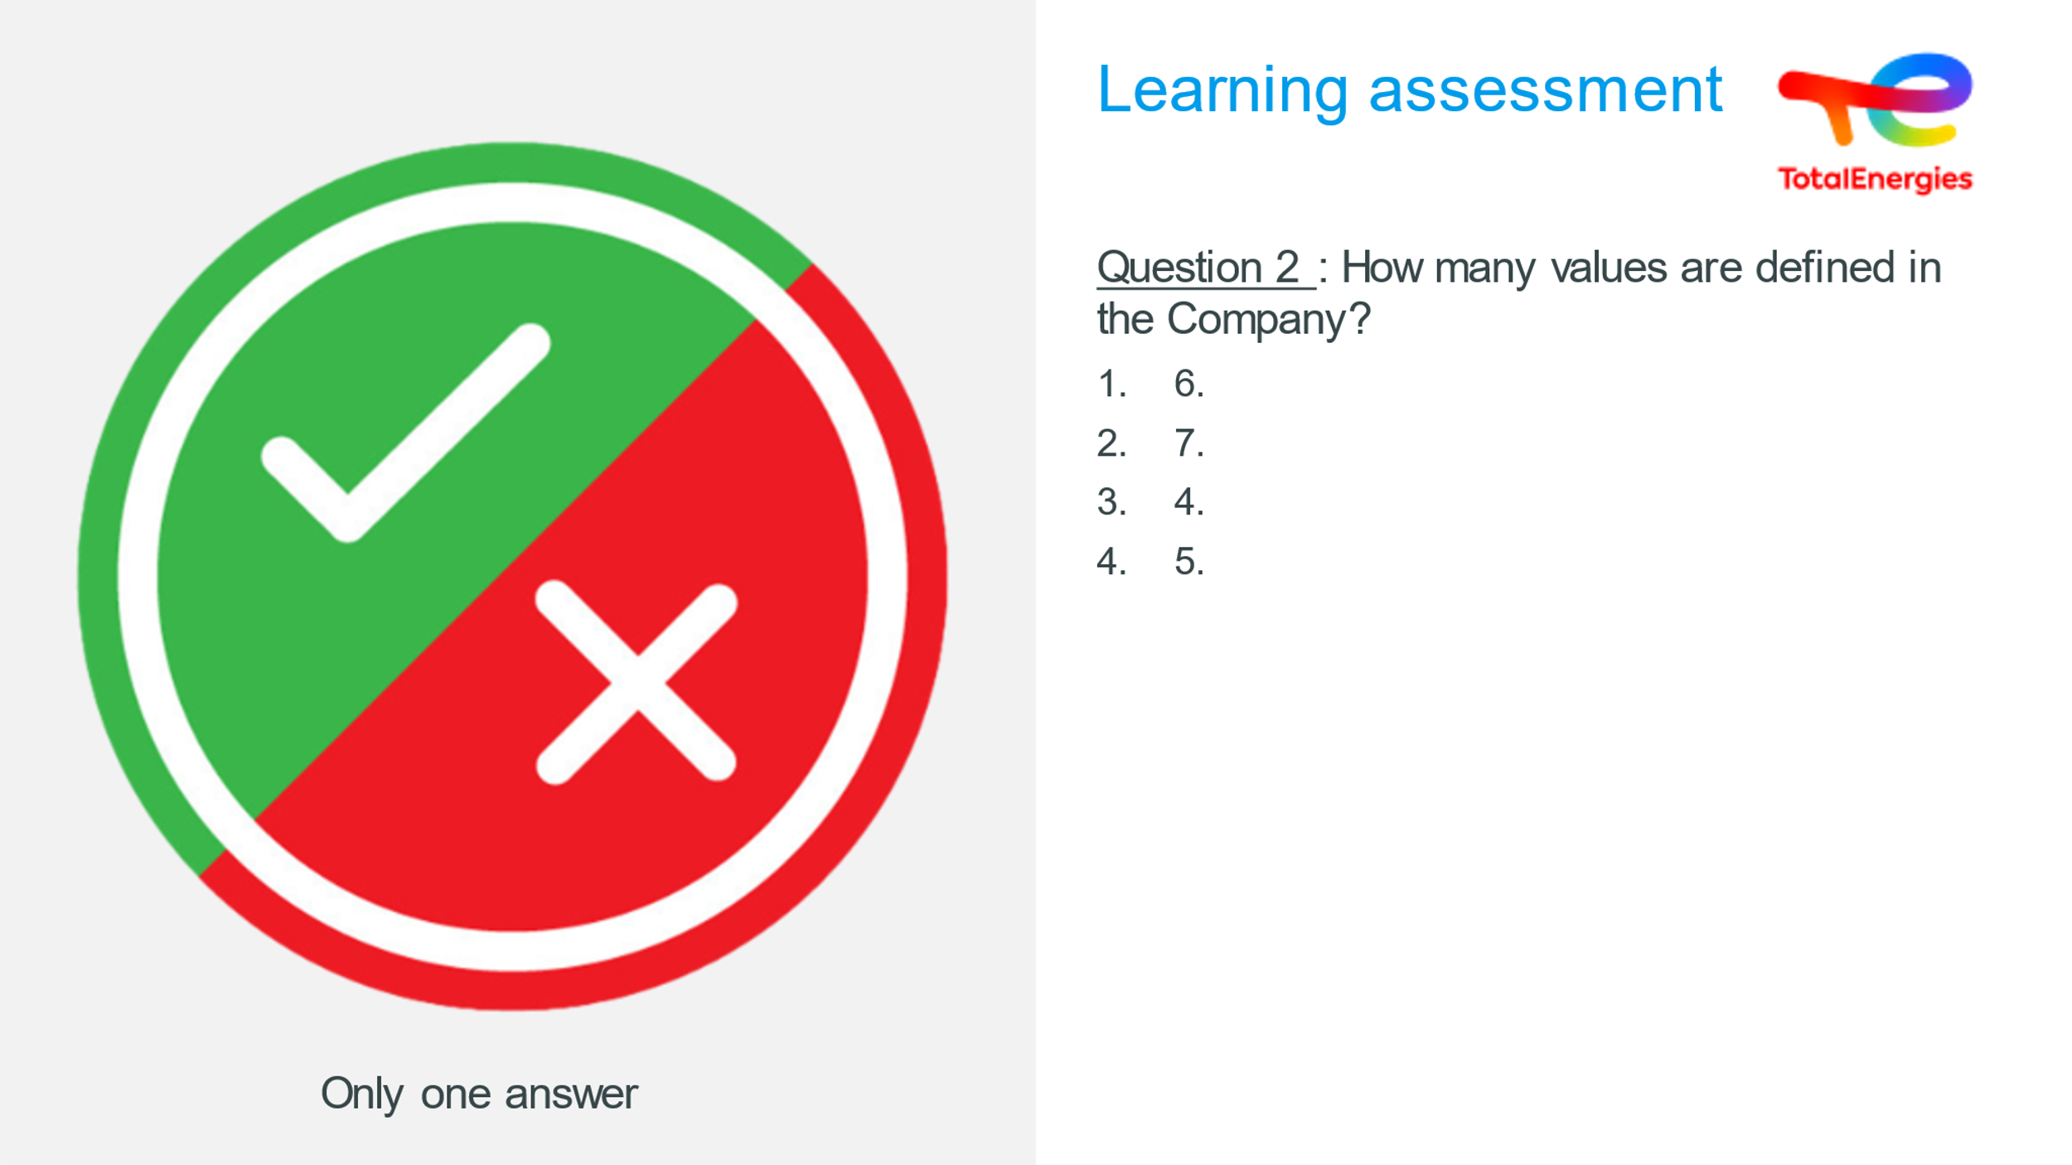
 | 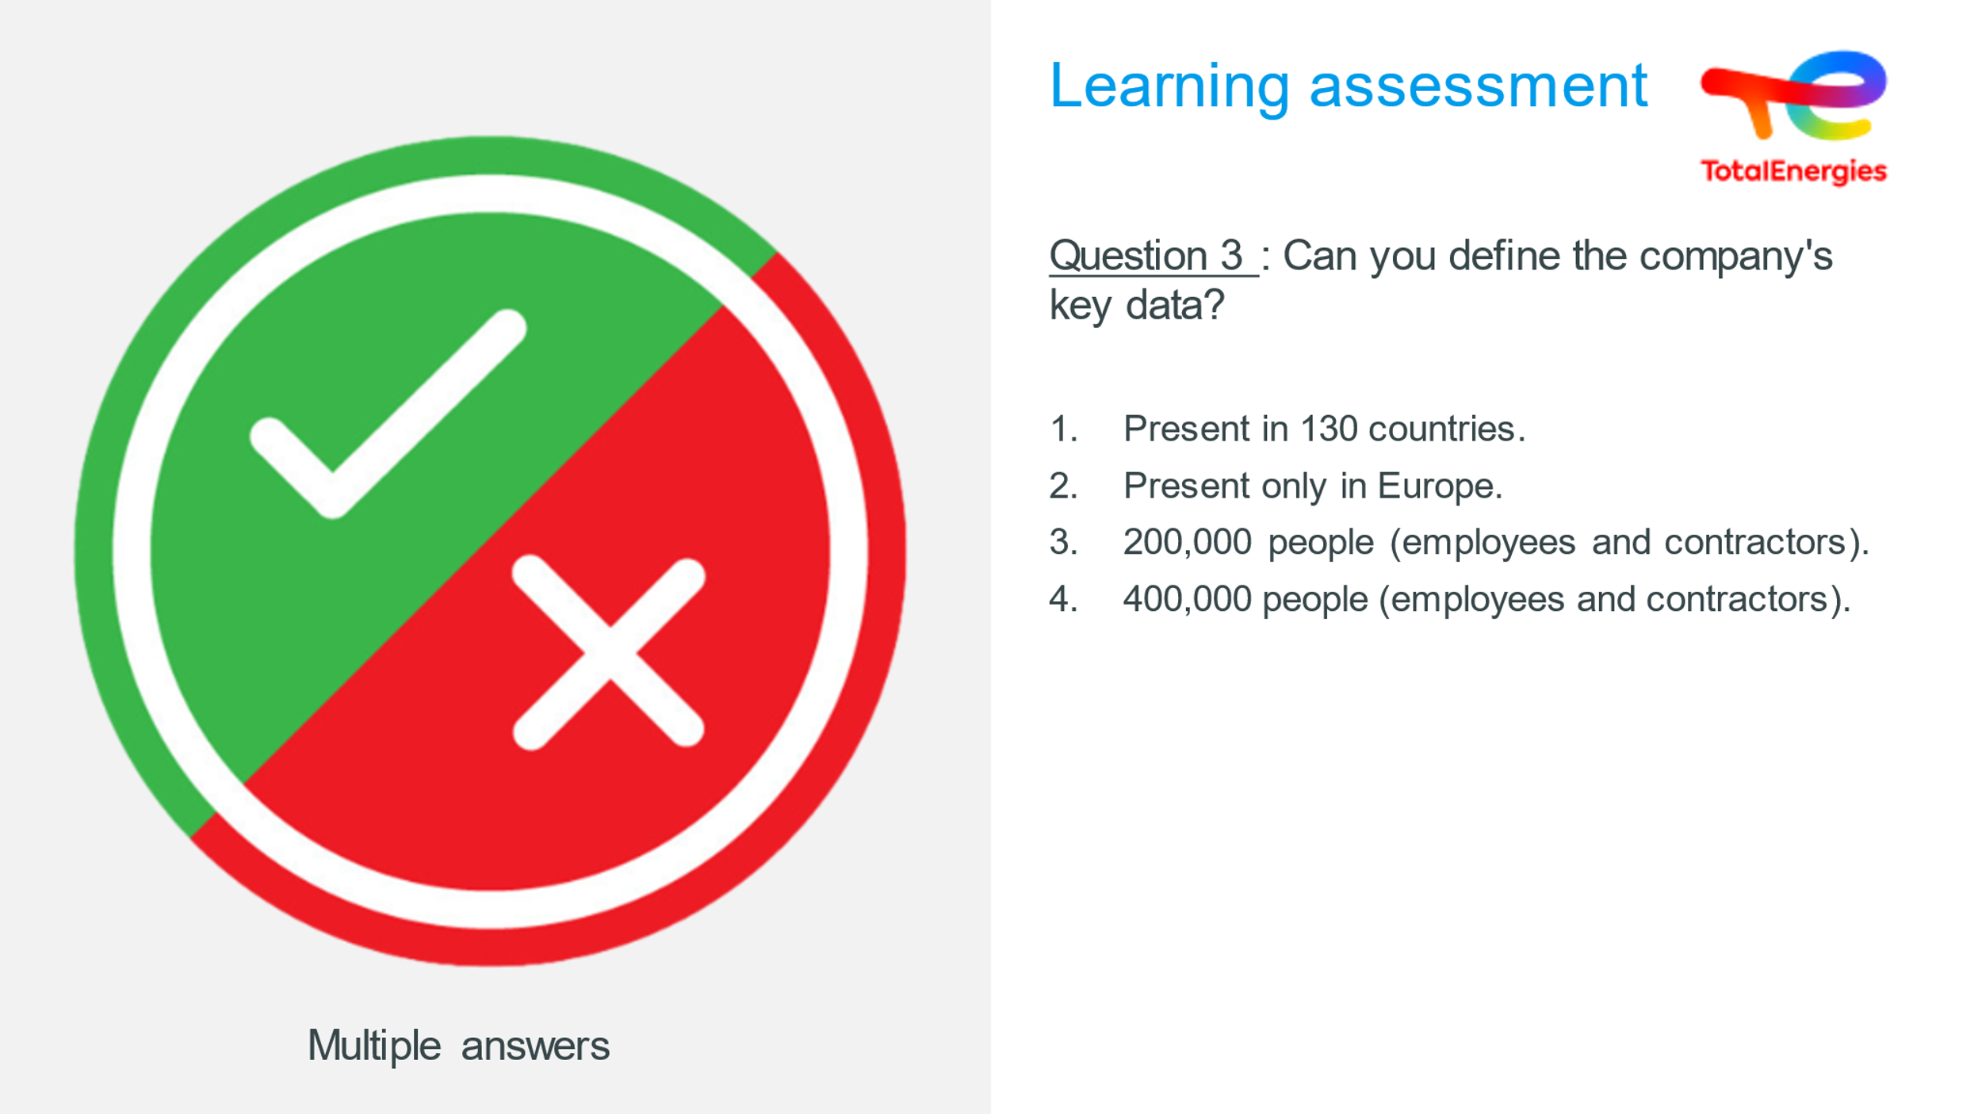
 | 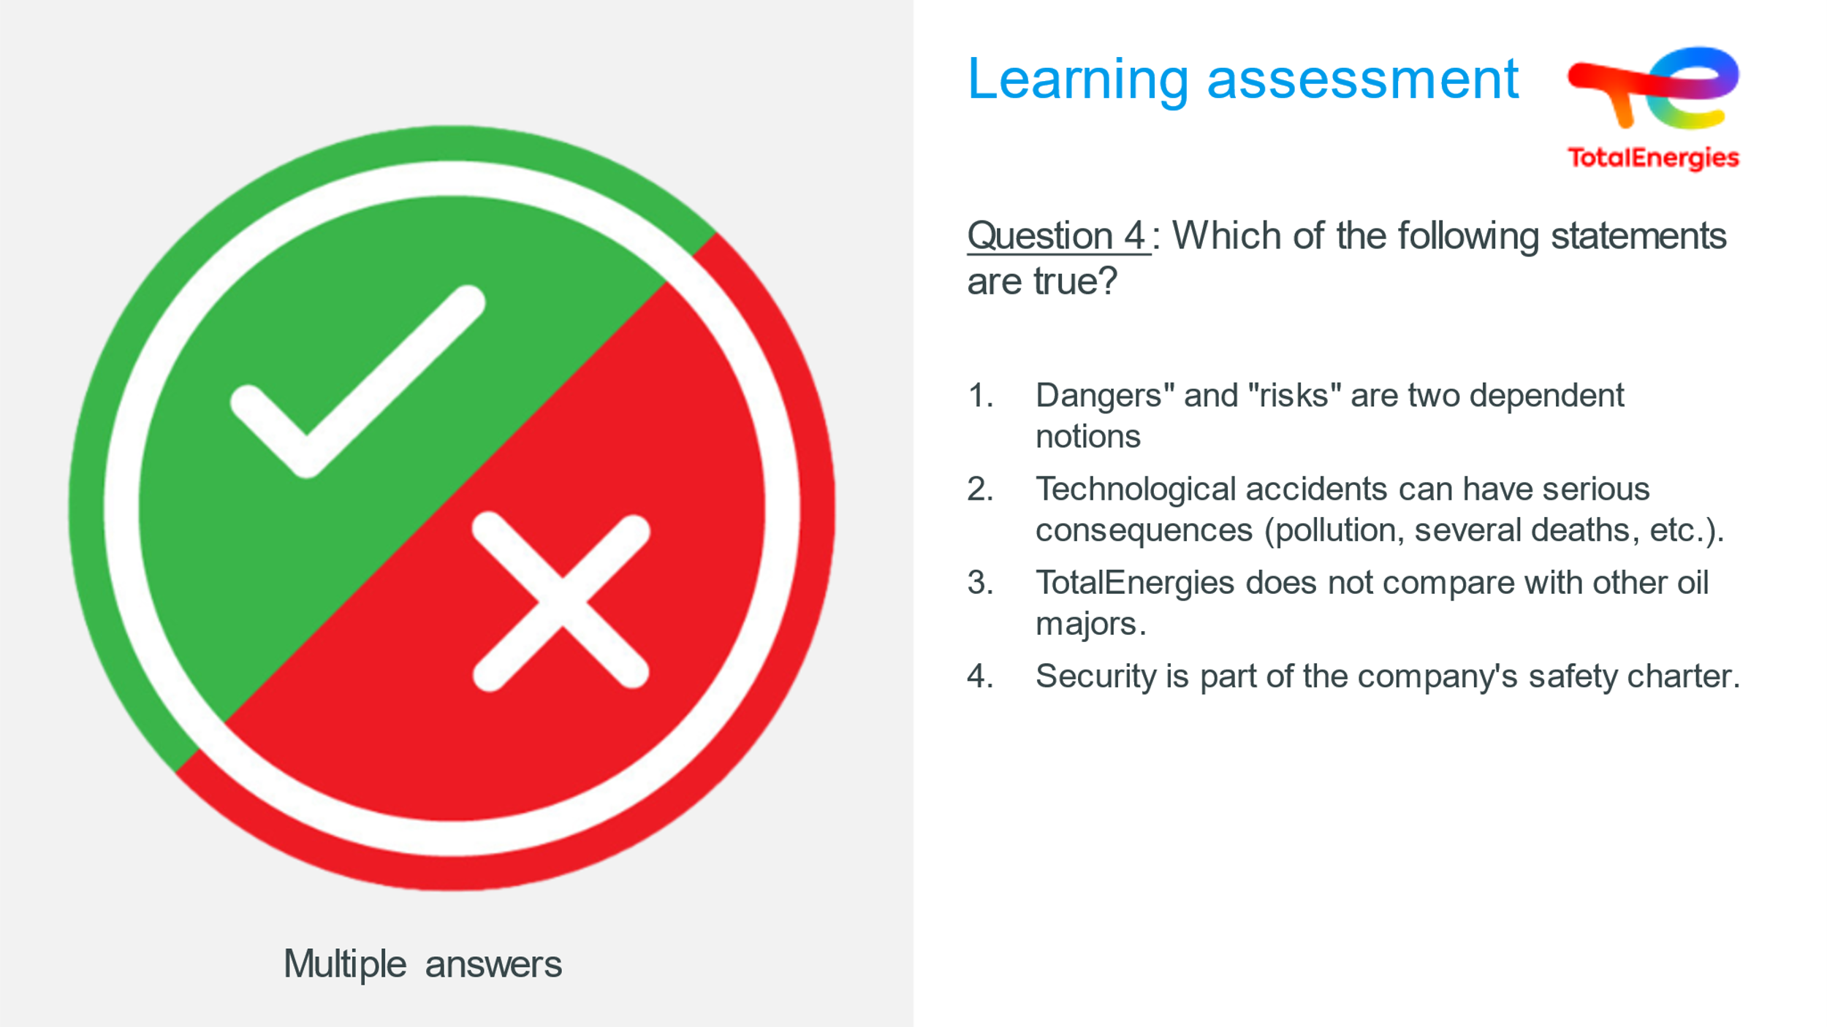
 | 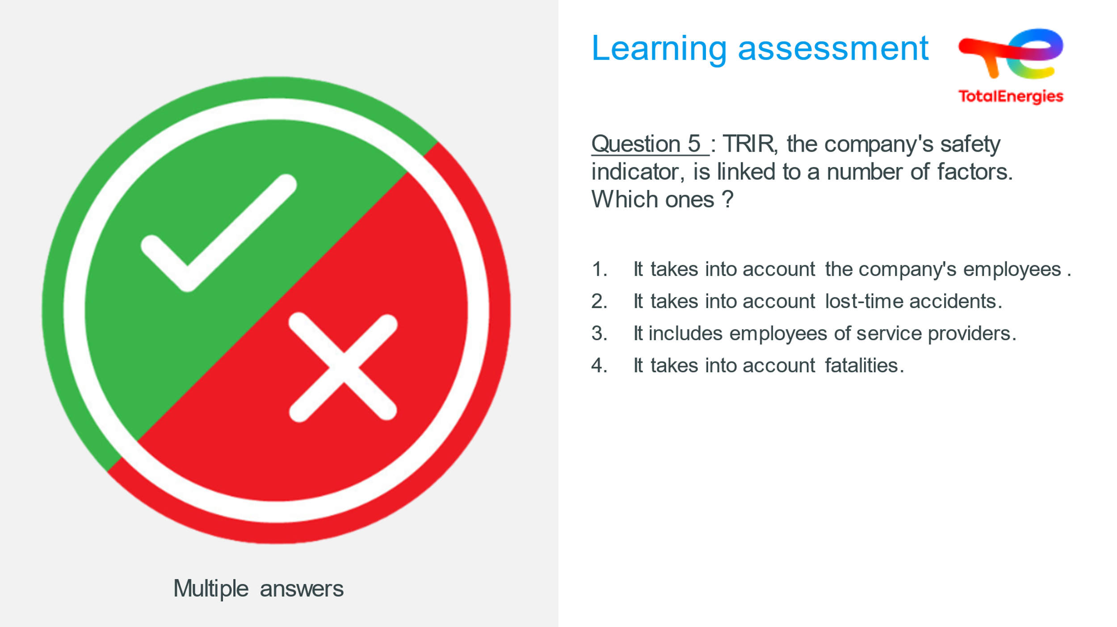
 | 
 | 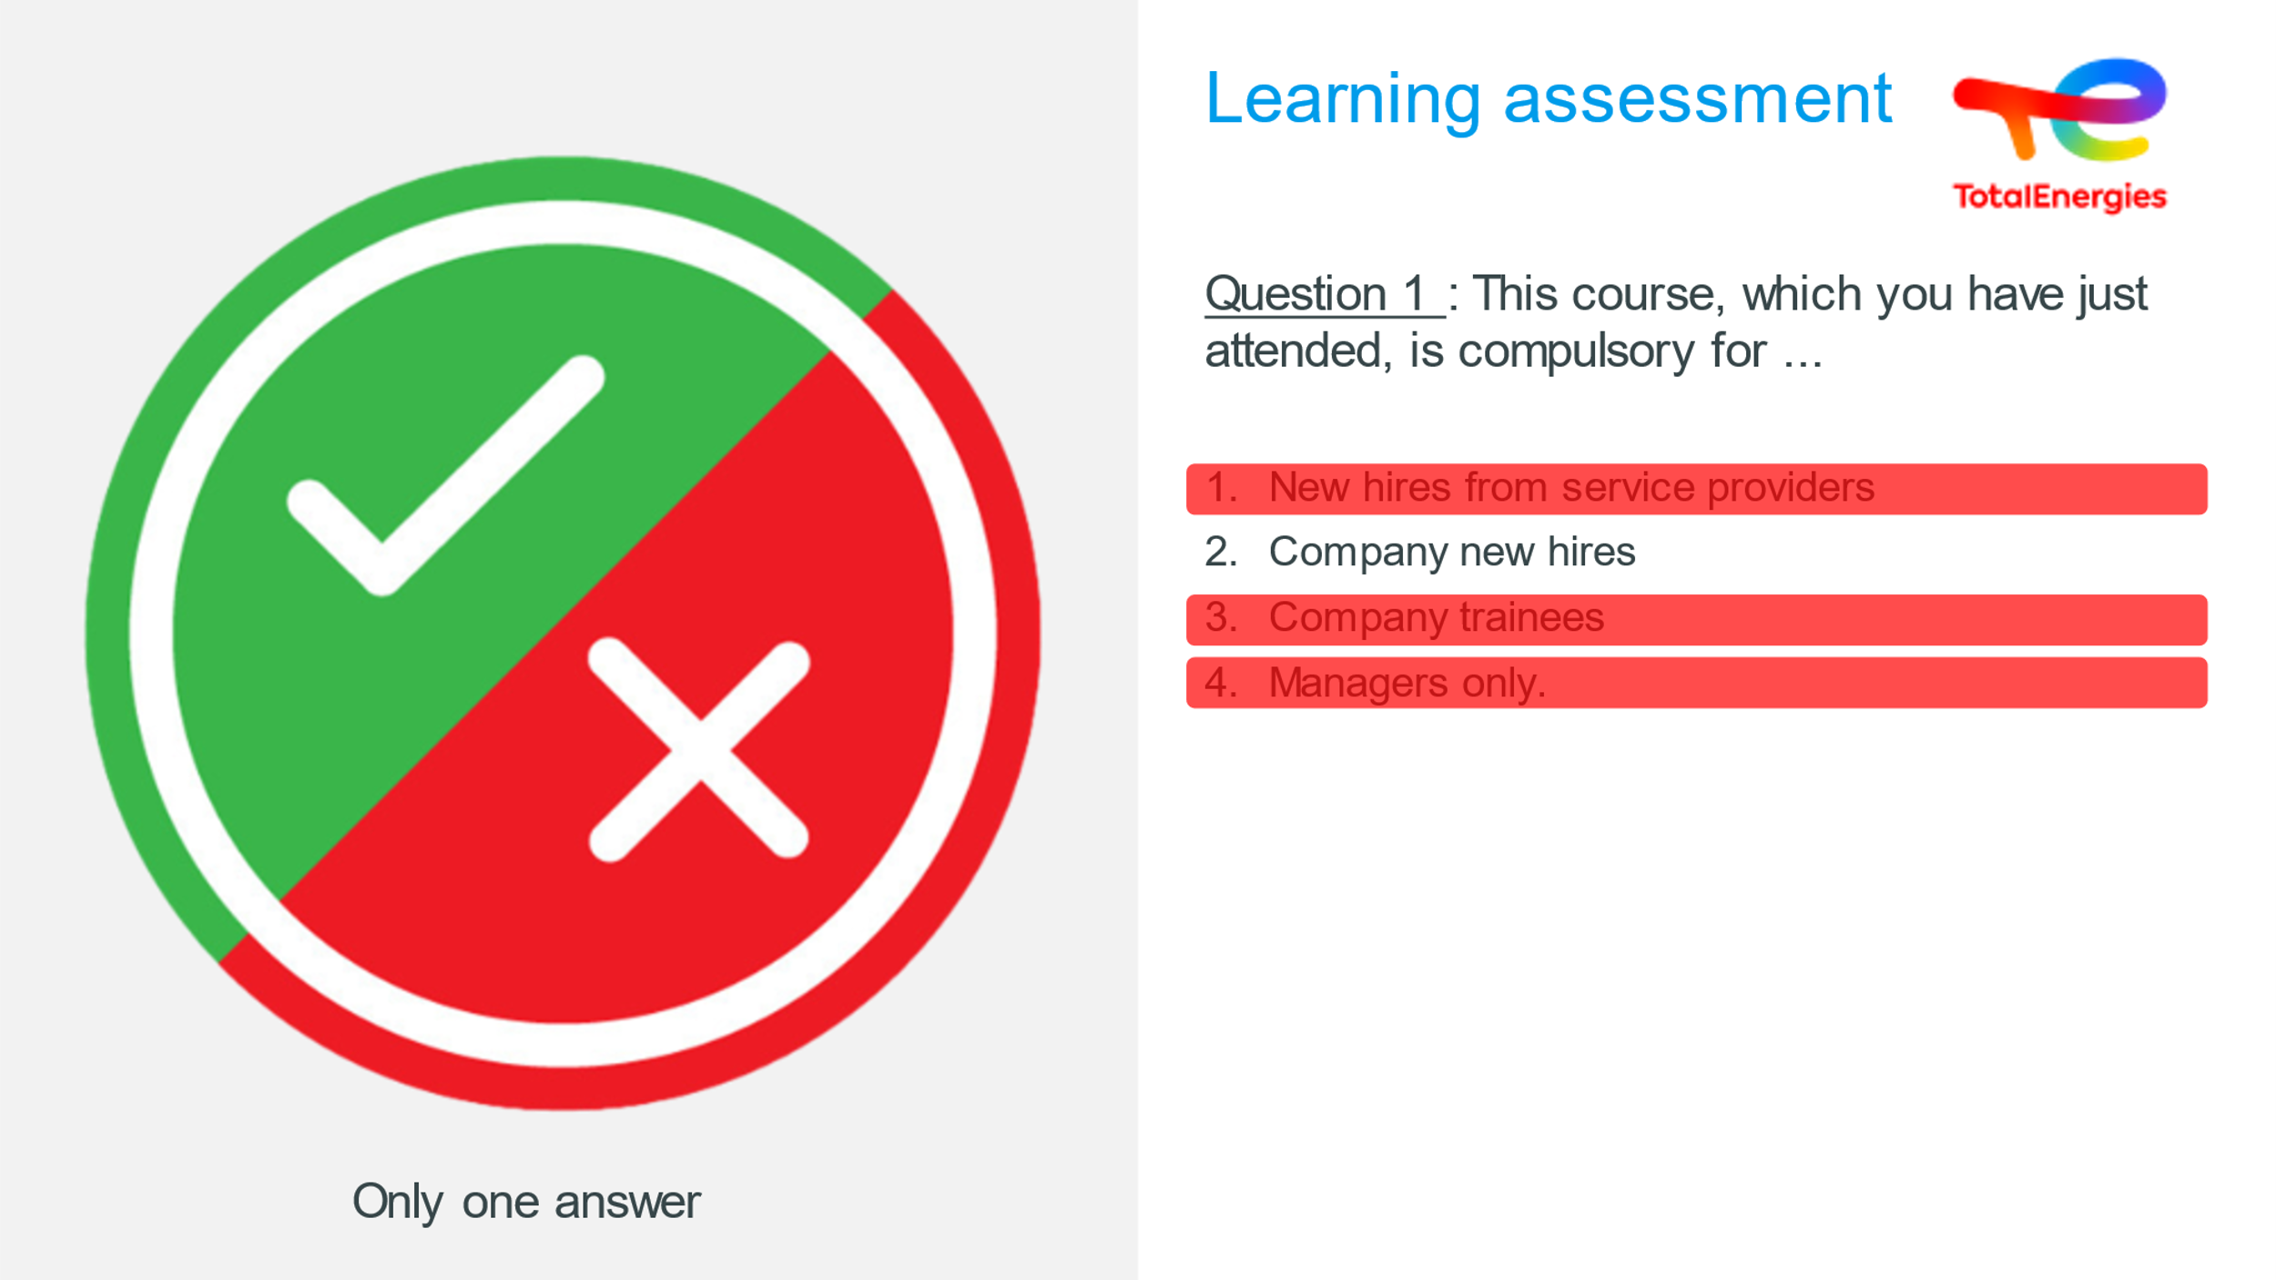 |  |  | Answer : 2
 | 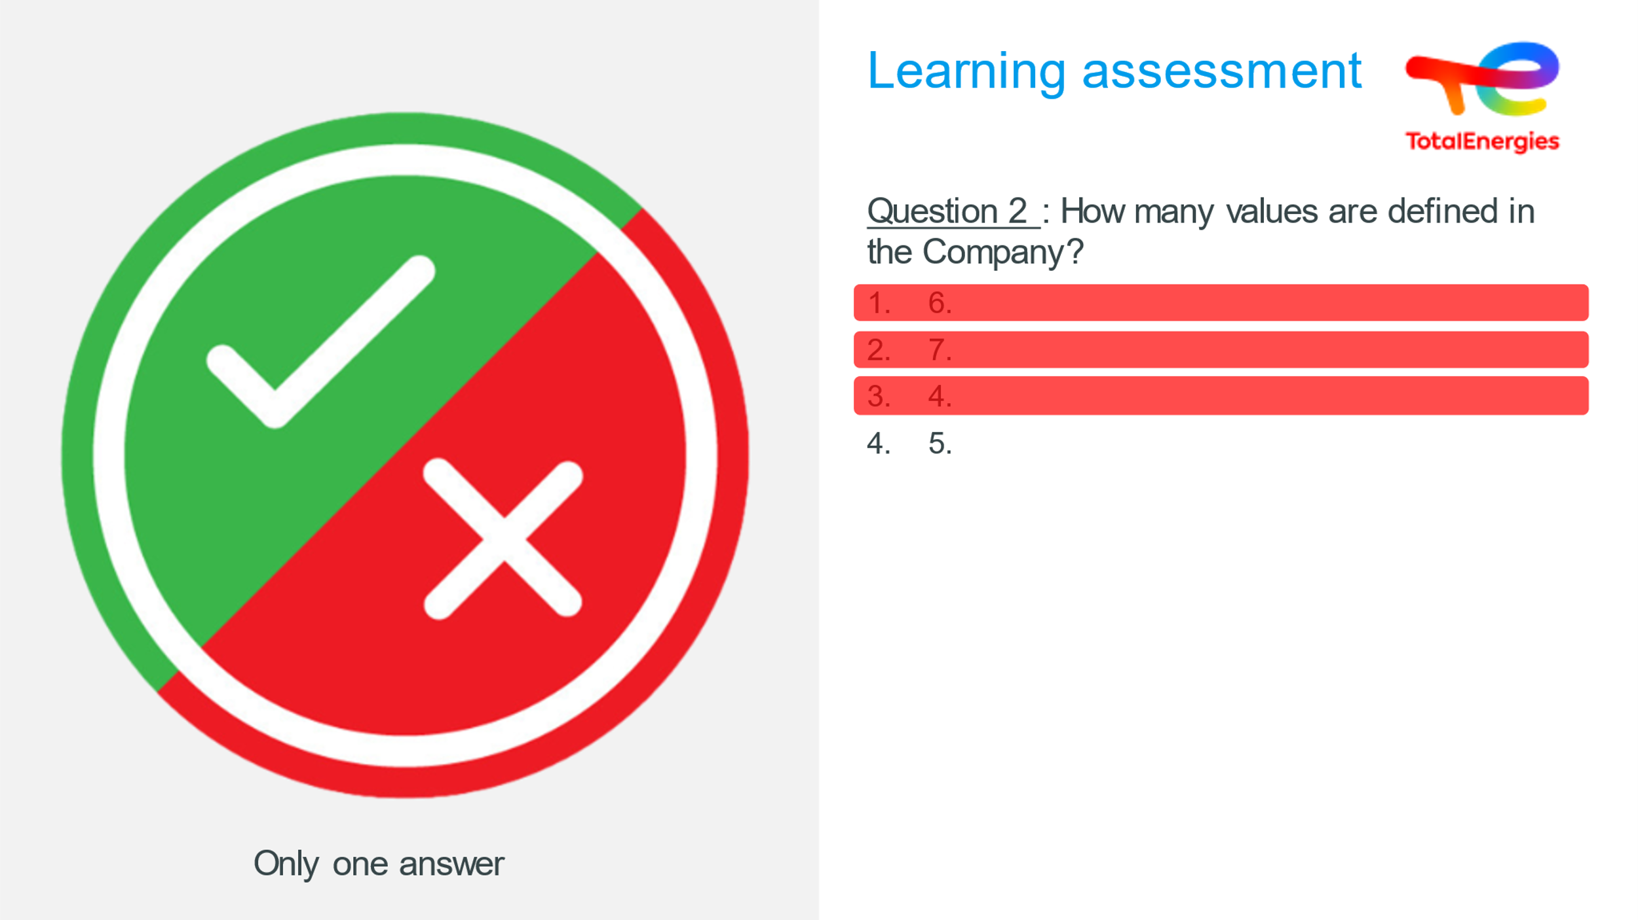 |  |  | Answer : 4
 | 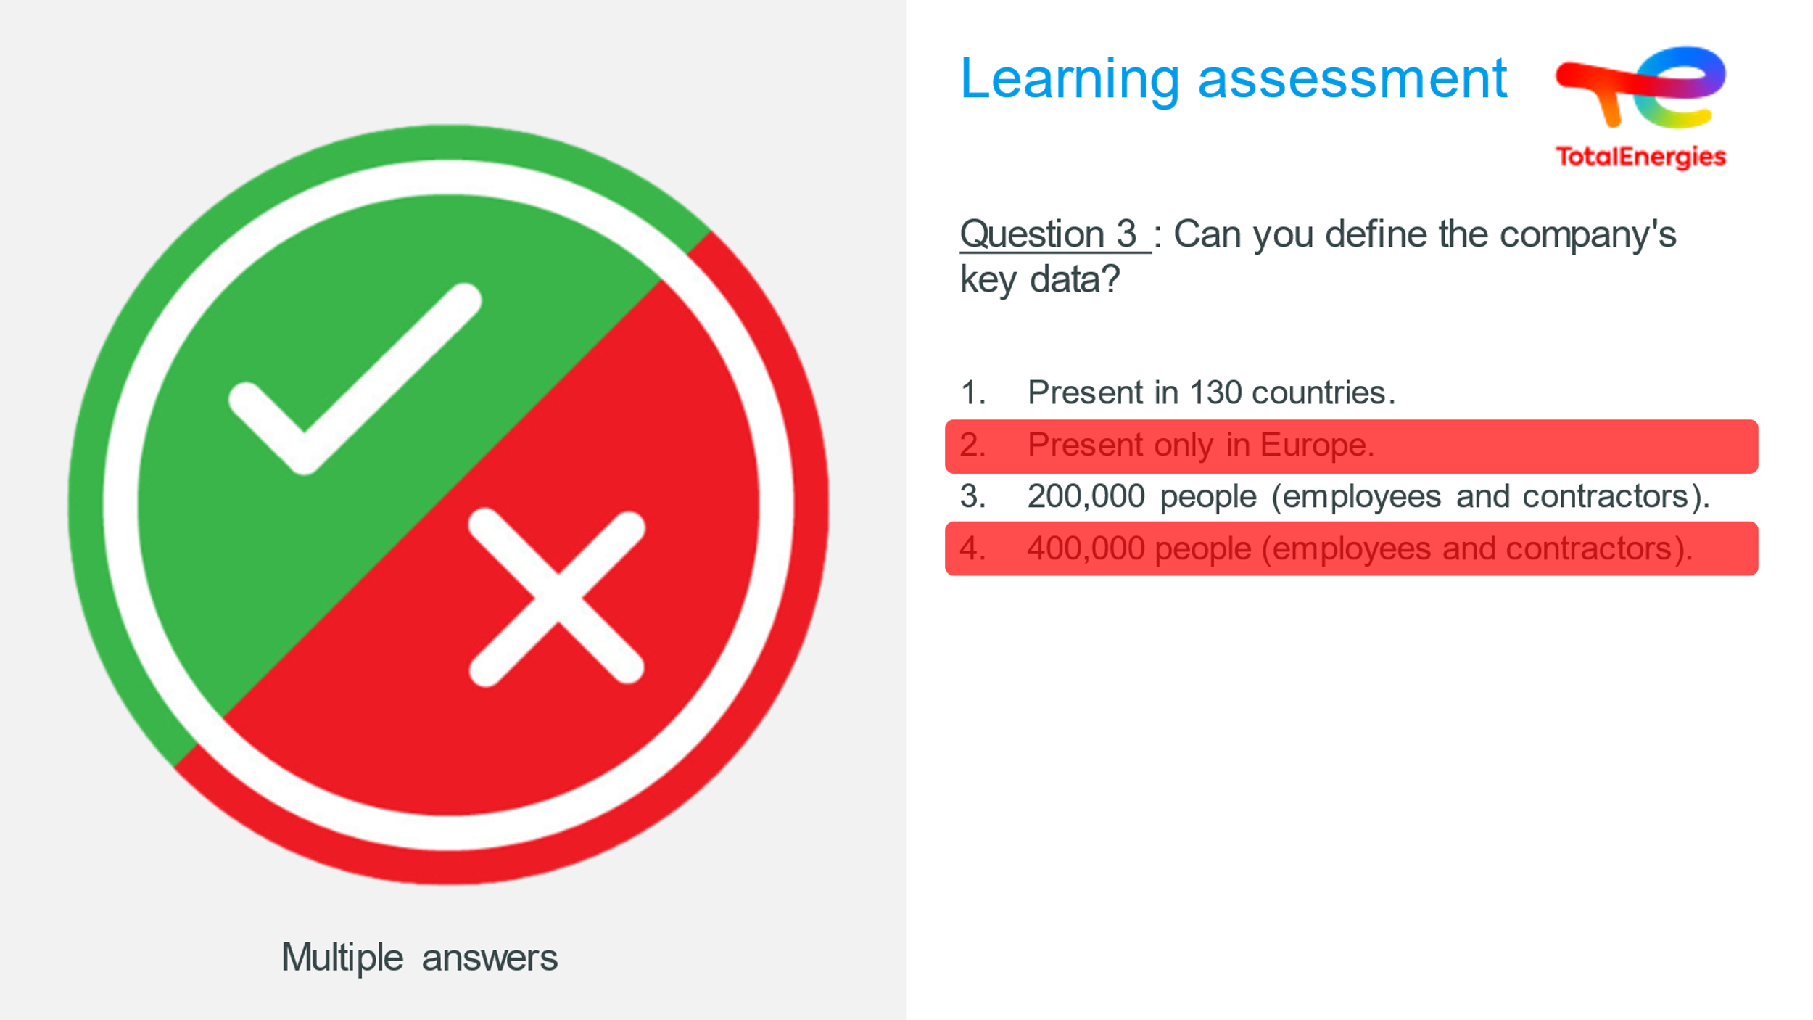 |  |  | Answer : 1 & 3
 | 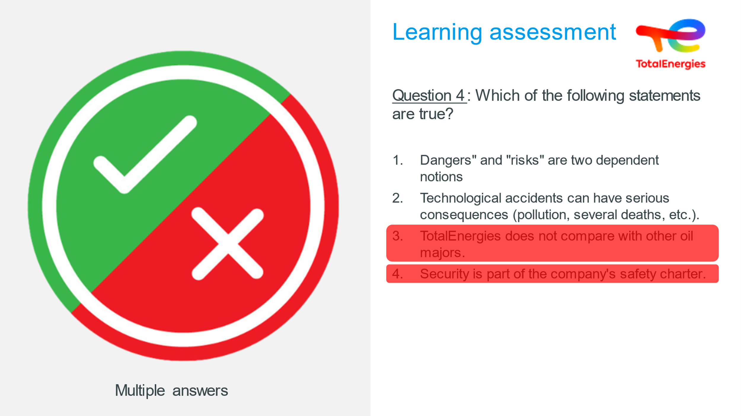 |  |  | Answer : 1 & 2
 | 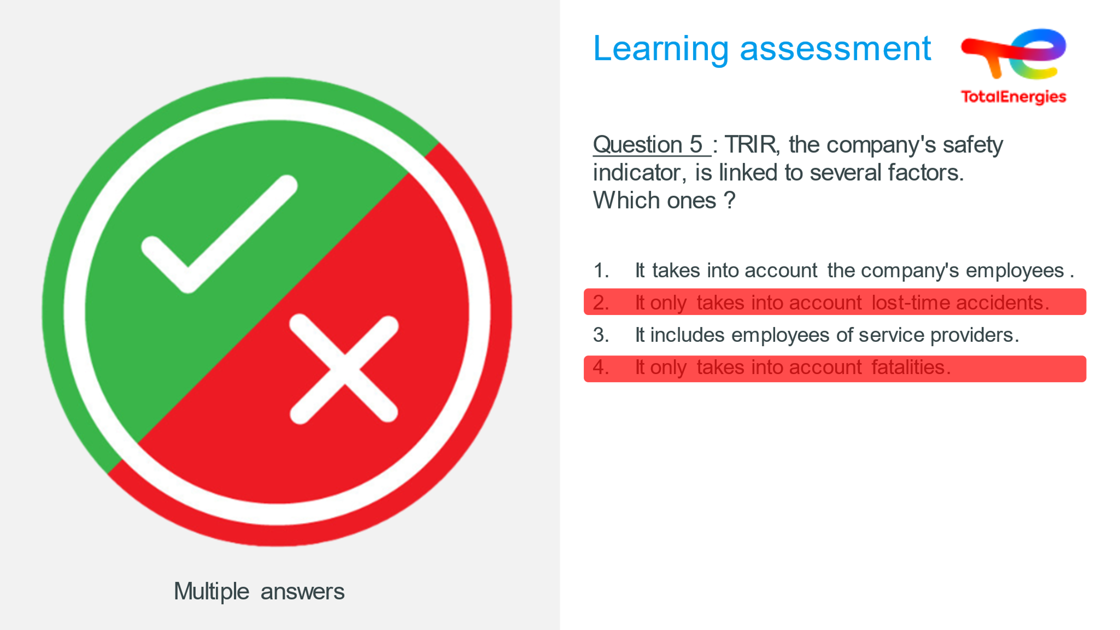 |  |  | Answer : 1 & 3
 | 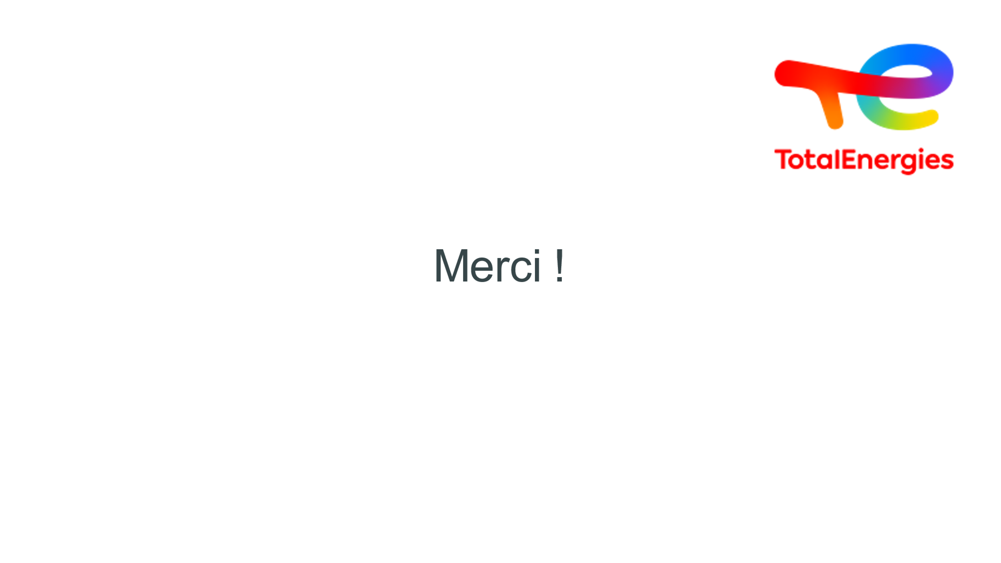 | Thank you |  | END OF WORKSHOP

