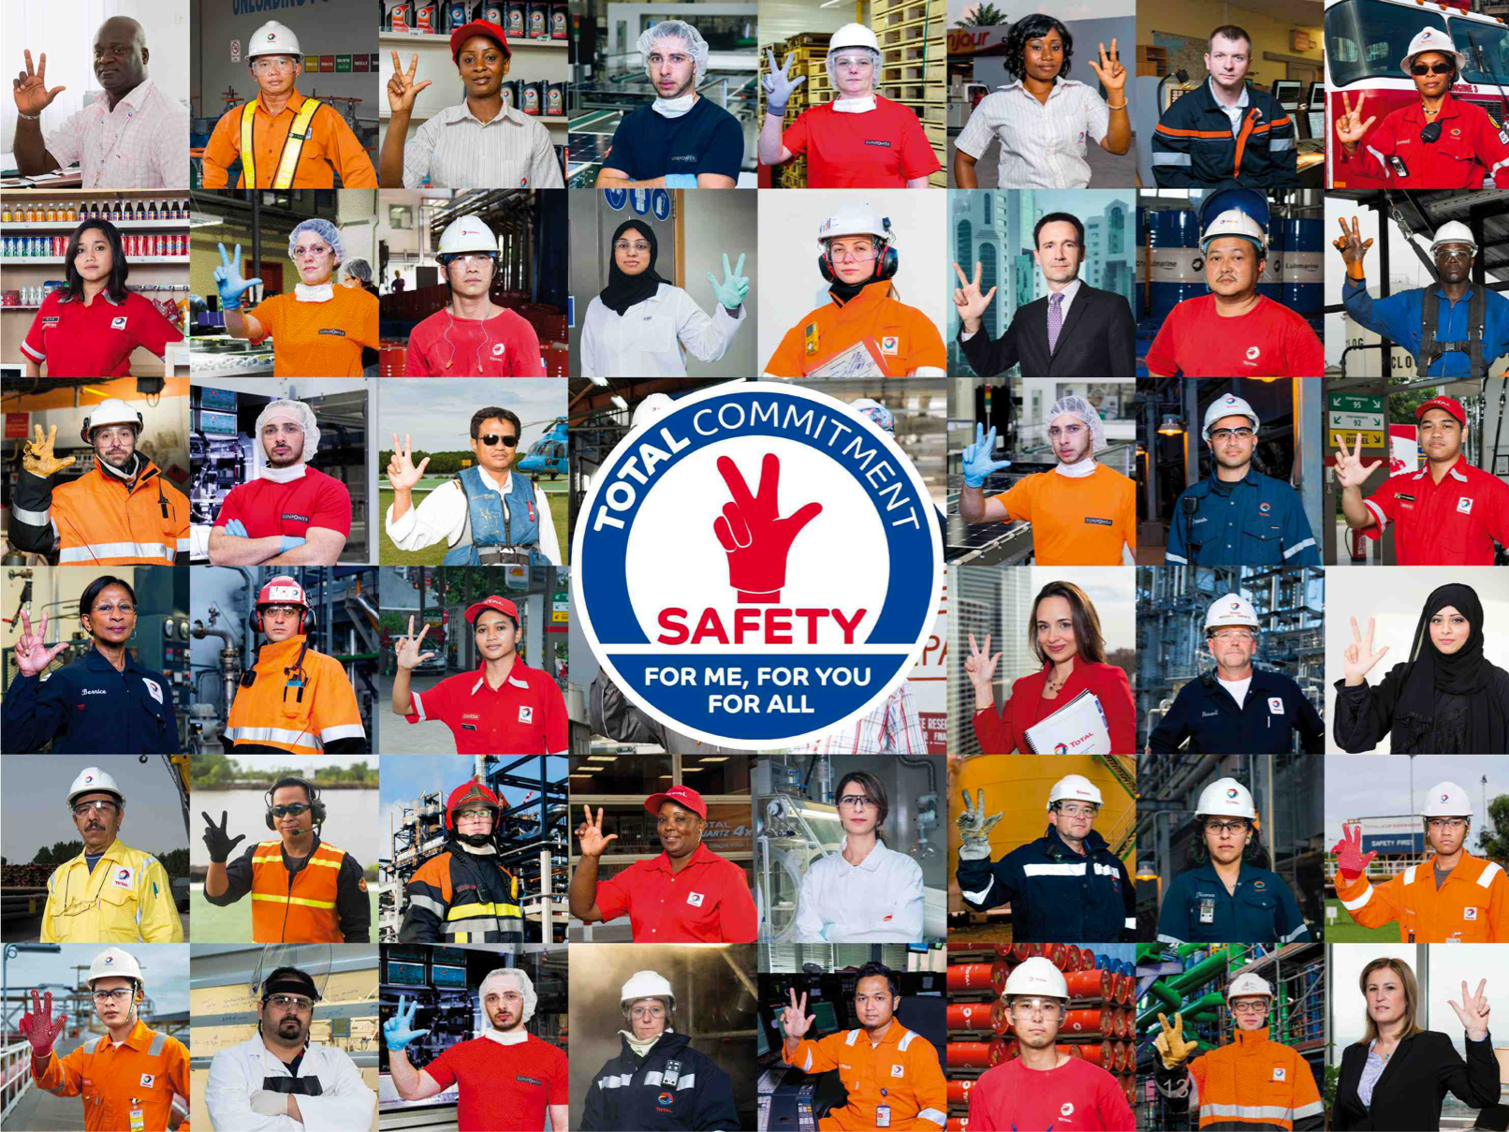
Your Safety training
Course n°1

Name:
Affiliate:
Position:

Introduction of Patrick Pouyanné
Managing Director of the Total Group

Dear colleague,
Welcome to our company.
Today, you will be starting our safety training. This approach is based on shared principles of standards, norms and group requirements across all entities, sites and affiliates, wherever you are in the world.
The modules that make up the course will allow you to grasp the essence of these principles. At the end of your training, you’ll be awarded a safety Pass.
This Pass is your key to joining us as a fully-fledged member of the Total family.
I wish you every success along the way. Happy training.

What happens during this course?

Your course
Your course consists of modules that you will follow. You will than have to get them validated by having the trainer sign your attendance sheet.
Your course starts as of the first day of your presence within the Total Group.
Once you will have gone through all the modules in your course, a “Safety Pass” certificate will be issued to you. It proves that you have the necessary safety skills to begin your activity at Total.
Your course is described in the following page.

The manual
You will keep this manual throughout your course, which will help you:
- validate the progression of your course,
- take notes,
- do the exercises,
- make your summary.

Timesheets
TCG 1.1
Introduction and commitment of
Top Management
Date:
Signature:
TCG 1.2
Safety as a value
Date:
Signature:
TCG 2.1
Our main HSE risks
Date:
Signature:
TCG 1.3
The HSEQ charter
Date:
Signature:
TCG 2.2
Technological risks
Major incidents
Date:
Signature:
TCG 2.3
Safety
Deaths and accidents
Date:
Signature:
TCG 3.1
One Maestro
HSE organization
Date:
Signature:
TCG 2.5b
Psychosocial risks
Date:
Signature:
TCG 4.1
Behavior
(positive and negative)
Date:
Signature:
TCG 4.2
Teamwork, manager relationships
Date:
Signature:
TCG 4.3
Relationships with contractors
Date:
Signature:
TCG 4.4
Everyone is responsible at their own level
Date:
Signature:
TCG 5.1
Golden rules
Sanction/Recognition
Date:
Signature:
TCG 5.2
Reporting anomalies
Date:
Signature:
TCG 5.3
Feedback
Date:
Signature:
TCG 5.4
Stop card
Date:
Signature:
TCG 7.0
Conclusions
Date:
Signature:
Timesheets
TCG 6.1
Fire fighting initiation
Date:
Signature:
TCG 6.2
First aid initiation
Date:
Signature:
TCAS 1.0
HSE roadmap
Site/affiliate
Date:
Signature:
TCAS 2.4
General safety rules
site/affiliate
Date:
Signature:
TCNT 1.1
Office accidents
Date:
Signature:
E
-
learning
Golden rules
Date:
Signature:
TCNT 1.4
On site exercise Stop card
Date:
Signature:
TCNT 1.3
Gestures and postures
Date:
Signature:
TCAS 1.1
Major risks and incidents
Date:
Signature:
TCAS 1.5
Psychosocial risks
Date:
Signature:
E
-
learning
Step in
Date:
Signature:
On site exercise report
and individual commitments
Date:
Signature:
Practical exercise
Hunt for anomalies initiation
Date:
Signature:
Practical exercise
Visit of muster points
Date:
Signature:
Practical exercise
Discovery and use
Stop card
Date:
Signature:
CONTENTS
Safety in the TOTAL Group 8
TCG 1.1: Introduction and Top Management Commitment 9
TCG 1.2: Safety as a value 10
TCG 1.3: The HSEQ Charter 11
TCG 2.2: Technological risks and major incidents 13
TCG 2.3: Safety: Deaths and accidents 14
TCG 2.5b: Psychosocial Risks 15
TCG 3.1: Maestro – HSE Organization 16
TCG 4.1: Behaviors (positive and negative) 17
TCG 4.2: Teamwork and manager relationships 19
TCG 4.3: Relationships with contractors - exemplary conduct 20
TCG 4.4: Everyone is responsible at their own level 21
TCG 5.1: The Golden Rules 22
TCG 5.2: Anomaly reporting 23
TCG 5.3: Feedback 25
TCG 5.4: Stop card 26
TCG 6.1: Fire fighting initiation 27
TCG 6.2: First aid initiation 28
TCG 7.0: Conclusion and commitments 29
Summary 30
Safety in my affiliate 31
TCAS 1.0: My affiliate’s HSE roadmap 32
TCAS 1.1: My affiliate’s major risks and incidents 33
TCAS 1.5: My affiliate’s psychosocial risks 34
TCAS 2.4: My affiliate’s general safety rules 35
Safety at my workstation 36
TCNT 1.1: Office incidents 37
TCNT 1.3: Gestures and postures 38
TCNT 1.4: On site exercise Stop card 39
Discovery report - Stop Card 40
Conclusion/Commitments 42
Conclusions of my course 43
My commitments 44

Safety in the TOTAL Group

TCG 1.1: Introduction and Top Management Commitment

What do you think are this video’s keywords and key ideas?

What stands out or surprises you the most in what Patrick Pouyanné says?

How could one summarize his commitment with respect to Safety?

TCG 1.2: Safety as a value

TCG 1.3: The HSEQ Charter

TCG 2.1: Our main safety risks

Exercise: TRIR calculation
Exercise 1 – Calculate your TRIR
Over the course of your career, assuming that you commit one infraction during it.
A career lasts on average 40 years, at a rate of 40 hours worked per week and 50 weeks per year.
Exercise 2 – Calculate the TRIR of a company
A company of 1000 employees counts 1 accident over one year (40 hours worked per week, and 50 weeks per annum).
Exercise 3
A company of 100,000 employees has 50 accidents per year (40 hours worked per week and 50 weeks per year).

TCG 2.2: Technological risks and major incidents

Exercise: Which consequences?
From this list, what do you think the consequences (on people, facilities, the company and neighbors) will be?
Accident | Consequences?
Oil slick
A car leaves the road and flips over 4 times
A person falls off a scaffold
Gas pipeline explosion
Fire in a storage tank
Falling down a staircase

TCG 2.3: Safety: Deaths and accidents

TCG 2.5b: Psychosocial Risks

TCG 3.1: Maestro – HSE Organization

Exercise: Which are the responsibilities of:
- John:

- The center manager:

- The instructor:

- Of each skydiver:

- An HSE technician, if John recruited one:

TCG 4.1: Behaviors (positive and negative)

Exercise: behavior or not?
- Working at height without a harness
- Being stressed
- Taking a Safety Tour
- Suggesting one of your colleagues take a Safety Tour
- Convincing yourself that safety is your priority
- Driving the wrong way on the highway

Exercise: error or fault?
- Speeding on-site
- Forgetting a big step in a procedure
- Bringing alcohol on-site
- Not understanding a plan or procedure
- Not using the PPE provided
- Confusing two chemical products
- Driving a site machine without wearing a seat belt
- Using a phone while driving
- Opening a different valve to the one indicated in the procedure because you don't think it is the right one

TCG 4.2: Teamwork and manager relationships

TCG 4.3: Relationships with contractors - exemplary conduct

Exercise: List everyone's safety actions and their differences
Operators:
- Site coordinator (Emile)

- Large construction company for major work

- Local craftsmen for joinery work

TCG 4.4: Everyone is responsible at their own level

TCG 5.1: The Golden Rules

TCG 5.2: Anomaly reporting

Exercise: finding anomalies

What anomalies did you identify?

In relation to these anomalies, what could have been done to prevent this accident?

TCG 5.3: Feedback

TCG 5.4: Stop card

TCG 6.1: Fire fighting initiation

TCG 6.2: First aid initiation

TCG 7.0: Conclusion and commitments

- Which actions would you like to implement in your future position to help reinforce the safety value?

- Which difficulties do you anticipate?

- Do you have any ideas yet on how to cope with these difficulties?

Summary

Safety in my affiliate

TCAS 1.0: My affiliate’s HSE roadmap

TCAS 1.1: My affiliate’s major risks and incidents

TCAS 1.5: My affiliate’s psychosocial risks

TCAS 2.4: My affiliate’s general safety rules

Safety at my workstation

TCNT 1.1: Office incidents

TCNT 1.3: Gestures and postures

TCNT 1.4: On site exercise Stop card

Discovery report - Stop Card

Under which circumstances have you intervened with the Stop Card?

How did people react?

What surprised you the most?

What did you learn from your intervention? And from the use of the Stop Card in general?

Conclusion/Commitments

Conclusions of my course

My commitments
Fill out this page only when your instructor asks you to.
Safety…
For me:

For you:

For all:

