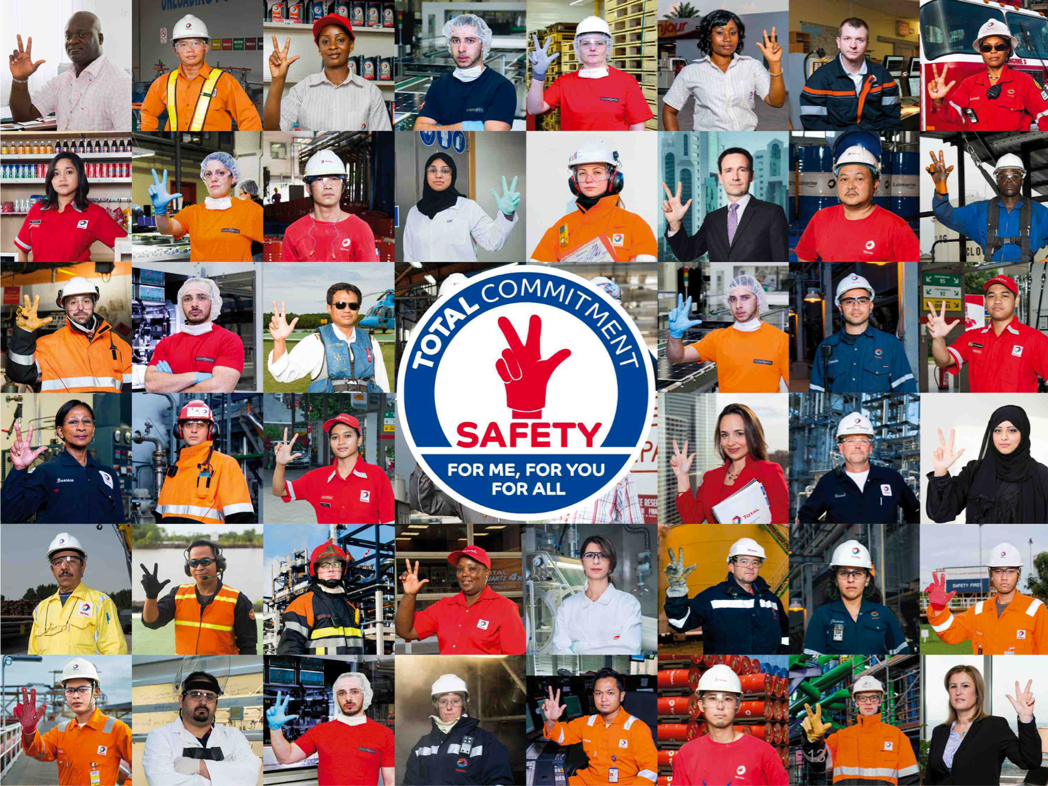
Your Safety training
Course n°2

Name:
Affiliate:
Position:

Introduction of Patrick Pouyanné
Managing Director of the Total Group

Hello dear colleagues,
Welcome to our company.
Today, you will be starting our safety training. This approach is based on shared principles of standards, norms and group requirements across all entities, sites and affiliates, wherever you are in the world.
The modules that make up the course will allow you to grasp the essence of these principles. At the end of your training, you’ll be awarded a safety Pass.
This Pass is your key to joining us as a fully-fledged member of the Total family.
I wish you every success along the way. Happy training.

What happens during these sessions?

Your course
Your course consists of modules that you will follow. You will then have to get them validated by having the trainer sign your attendance sheet.
Your course starts as of the first day of your presence within the Total Group.
Once you will have gone through all the modules in your course, a “Safety Pass” certificate will be issued to you. It proves that you have the necessary safety skills to begin your activity at Total.
Your course is described in the following pages.
The manual
You will keep this manual throughout your course, which will help you:
- validate the progression of your course,
- take notes,
- do the exercises,
- make your summary.

Timesheets
TCG 1.1
Introduction and commitment of
Top Management
Date:
Signature:
TCG 1.2
Safety as a value
Date:
Signature:
TCG 2.1
Our main HSE risks
Date:
Signature:
TCG 1.3
The HSEQ charter
Date:
Signature:
TCG 2.2
Technological risks
Major incidents
Date:
Signature:
TCG 2.3
Safety
Deaths and accidents
Date:
Signature:
TCG 3.1
One Maestro
HSE organization
Date:
Signature:
TCG 2.5b
Psychosocial risks
Date:
Signature:
TCG 4.1
Behavior
(positive and negative)
Date:
Signature:
TCG 4.2
Teamwork, manager relationships
Date:
Signature:
TCG 4.3
Relationships with contractors - exemplary conduct
Date:
Signature:
TCG 4.4
Everyone is responsible at their own level
Date:
Signature:
TCG 5.1
Golden Rules
Sanction/Recognition
Date:
Signature:
TCG 5.2
Reporting anomalies
Date:
Signature:
TCG 5.3
Feedback
Date:
Signature:
TCG 5.4
Stop Card
Date:
Signature:
TCG 7.0
Conclusions
Date:
Signature:
Timesheets
TCAS 1.0
HSE roadmap
Site/affiliate
Date:
Signature:
TCAS 2.1
Country regulations
Date:
Signature:
TCAS 1.1
Major risks and accidents
TCAS 1.5
Psychosocial risks
Date:
Signature:
TCAS 2.5
Personal protective equipment
Date:
Signature:
TCAS 2.6
Problematic golden rules
Date:
Signature:
TCAS 2.7
Action to be taken in the event of an emergency
Date:
Signature:
TCAS 2.6
On site exercise
Application of the golden rules
Date:
Signature:
TCAS 2.7
On site exercise:
Mustering
Date:
Signature:
TCAS 3.1
Safety technical standards and associated tools
Date:
Signature:
TCAS 3.2
Affiliate HSE organization
Date:
Signature:
TCAS 3.3
Site visit
Date:
Signature:
TCAS 3.3
Workshop: feedback of the site visit
Date:
Signature:
TCAS 4.1
Events analysis
Date:
Signature:
TCAS 4.2
Specific HSE activities
Date:
Signature:
TCAS 4.2
On site exercise Specific HSE activities
Date:
Signature:
TCAS 4.3
Experience feedback
Date:
Signature:
TCAS 4.3
On site exercise
Experience feedback
Date:
Signature:
TCAS 2.4
General safety rules
site/affiliate
Date:
Signature:
Date:
Signature:
Timesheets
Office incidents
TCG 5.4
TCG 5.4
On site exercise Stop card
Signature:
Date:
Signature:
Date:
Discovery report
Stop Card
Signature:
Date:
TCNT 1.1
TCNT 1.3
Gestures and postures
Signature:
Date:
TCG 6.1
Fire fighting initiation
Date:
Signature:
TCG 6.2
First aid initiation
Date:
Signature:
E
-
learning
Golden Rules
Date:
Signature:
E
-
learning
Step in
Date:
Signature:
On site exercise report and individual commitments
Date:
Signature:
Practical exercise
Hunt for anomalies initiation
Date:
Signature:
Practical exercise
Visit of muster points
Date:
Signature:
Practical exercise
Discovery and use
Stop Card
Date:
Signature:

CONTENTS
Introduction de Patrick Pouyanné 2
Comment cela va-t-il se passer ? 3
Sécurité dans le Groupe TOTAL 9
TCG 1.1 : Introduction et engagement Top Management 10
TCG 1.2 : Valeur Sécurité 11
TCG 1.3 : La Charte HSEQ 12
TCG 2.2 : Risques Technologiques et accidents majeurs 14
TCG 2.3 : Sécurité : Morts et accidents 15
TCG 2.5b : Les Risques Psychosociaux 16
TCG 3.1 : Maestro - Organisation HSE 17
TCG 4.1 : Les comportements (positifs et négatifs) 18
TCG 4.2 : Travail en équipe et relations hiérarchiques 20
TCG 4.3 : Relations avec les contractants - Exemplarité 21
TCG 4.4 : Chacun à son niveau est responsable 22
TCG 5.1 : Les règles d’or 23
TCG 5.2 : Remontée d’anomalies 24
TCG 5.3 : Le retour d’expérience 26
TCG 5.4 : Stop Card 27
TCG 6.1 : Initiation lutte incendie 28
TCG 6.2 : Initiation au secourisme 29
TCG 7.0 : Conclusion et engagements 30
Synthèse 31
Sécurité dans ma filiale 32
TCAS 1.0 : Feuille de route HSE de ma filiale 33
TCAS 1.1 : Les risques et accidents majeurs de ma filiale 34
TCAS 1.5 : Les risques psychosociaux de ma filiale 35
TCAS 2.4 : Les règles générales de sécurité de ma filiale 36
TCAS 2.5 : Equipement de protection individuel 37
TCAS 2.6 : Règles d’or problématiques 38
TCAS 2.6 : Expérimentation application des règles d’or 39
TCAS 2.7 : Conduite à tenir en cas d’urgence 40
TCAS 2.7 : Expérimentation exercice d’évacuation 41
TCAS 3.1 : Référentiel sécurité et outils associés 42
TCAS 3.2 : Organisation HSE filiale 43
TCAS 3.3 : Visite de site 44
TCAS 3.3 : Atelier de restitution de la visite de site 45
TCAS 4.1 : Analyse des évènements 46
TCAS 4.2 : Activités HSE spécifiques 47
TCAS 4.2 : Expérimentation activités HSE spécifiques 48
TCAS 4.3 : REX 49
TCAS 4.3 : Expérimentation REX 50
Sécurité à mon poste 51
TCNT 1.1 : Les accidents de bureau 52
TCNT 1.3 : Les gestes et postures 53
TCG 5.4 : Stop Card expérimentation 54
TCG 5.4 : Rapport d’étonnement - Stop Card 55
Conclusion/Engagements 57
Conclusion de mon parcours 58
Mes engagements 59

Safety in the TOTAL Group

TCG 1.1: Introduction and Top Management Commitment

What do you think are this video’s keywords and key ideas?

What stands out or surprises you the most in what Patrick Pouyanné says?

How could one summarize his commitment with respect to Safety?

TCG 1.2: Safety as a value

TCG 1.3: The HSEQ Charter

TCG 2.1: Our main safety risks

Exercise: TRIR calculation
Exercise 1 – Calculate your TRIR
Over the course of your career, assuming that you commit one infraction during it.
A career lasts on average 40 years, at a rate of 40 hours worked per week and 50 weeks per year.
Exercise 2 – Calculate the TRIR of a company
A company of 1000 employees counts 1 accident over one year (40 hours worked per week, and 50 weeks per annum).
Exercise 3
A company of 100,000 employees has 50 accidents per year (40 hours worked per week and 50 weeks per year).

TCG 2.2: Technological risks and major incidents

Exercise: Which consequences?
From this list, what do you think the consequences (on people, facilities, the company and neighbors) will be?
Accident | Consequences?
Oil slick
A car leaves the road and flips over 4 times
A person falls off a scaffold
Gas pipeline explosion
Fire in a storage tank
Falling down a staircase

TCG 2.3: Safety: Deaths and accidents

TCG 2.5b: Psychosocial Risks

TCG 3.1: Maestro – HSE Organization

Exercise: Which are the responsibilities of:
- John:

- The center manager:

- The instructor:

- Of each skydiver:

- An HSE technician, if John recruited one:

TCG 4.1: Behaviors (positive and negative)

Exercise: behavior or not?
- Working at height without a harness
- Being stressed
- Taking a Safety Tour
- Suggesting one of your colleagues take a Safety Tour
- Convincing yourself that safety is your priority
- Driving the wrong way on the highway

Exercise: error or fault?
- Speeding on-site
- Forgetting a big step in a procedure
- Bringing alcohol on-site
- Not understanding a plan or procedure
- Not using the PPE provided
- Confusing two chemical products
- Driving a site machine without wearing a seat belt
- Using a phone while driving
- Opening a different valve to the one indicated in the procedure because you don't think it is the right one

TCG 4.2: Teamwork and manager relationships

TCG 4.3: Relationships with contractors - exemplary conduct

Exercise: List everyone's safety actions and their differences
Operators:
- Site coordinator (Emile)

- Large construction company for major work

- Local craftsmen for joinery work

TCG 4.4: Everyone is responsible at their own level

TCG 5.1: The Golden Rules

TCG 5.2: Anomaly reporting

Exercise: finding anomalies

What anomalies did you identify?

In relation to these anomalies, what could have been done to prevent this accident?

TCG 5.3: Feedback

TCG 5.4: Stop Card

TCG 6.1: Fire fighting initiation

TCG 6.2: First aid initiation

TCG 7.0: Conclusion and commitments

- Which actions would you like to implement in your future position to help reinforce the safety value?

- Which difficulties do you anticipate?

- Do you have any ideas yet on how to cope with these difficulties?

Summary

Safety in my affiliate

TCAS 1.0: My affiliate’s HSE roadmap

TCAS 1.1: My affiliate’s major risks and incidents

TCAS 1.5: My affiliate’s psychosocial risks

TCAS 2.4: My affiliate’s general safety rules

TCAS 2.5: Personal protective equipment

TCAS 2.6: Problematic golden rules

TCAS 2.6: On site exercise on the application of the golden rules

TCAS 2.7: Action to be taken in the event of an emergency

TCAS 2.7: Fire drill on site exercise

TCAS 3.1: Safety technical standards and associated tools

TCAS 3.2: Affiliate HSE organization

TCAS 3.3: Site visit

TCAS 3.3: Workshop: feedback of the site visit

TCAS 4.1: Events analysis

TCAS 4.2: Specific HSE activities

TCAS 4.2: On site exercise on specific HSE activities

- What surprised you the most when you took part in the event?

- What were the strong point(s) that surprised you most?

- What were the most unexpected weak points(s) for you? What are your suggestions for improving these weaknesses?

TCAS 4.3: Experience feedback

TCAS 4.3: On site exercise experience feedback

Safety at my workstation

TCNT 1.1: Office incidents

TCNT 1.3: Gestures and postures

TCG 5.4: On site exercise stop card

TCG 5.4: Discovery report - Stop card

Under which circumstances have you intervened with the Stop Card?

How did people react?

What surprised you the most?

What did you learn from your intervention? And from the use of the Stop Card in general?

Conclusion/Commitments

Conclusion of my course

My commitments
Fill out this page only when your instructor asks you to.
Safety…
For me:

For you:

For everyone:

