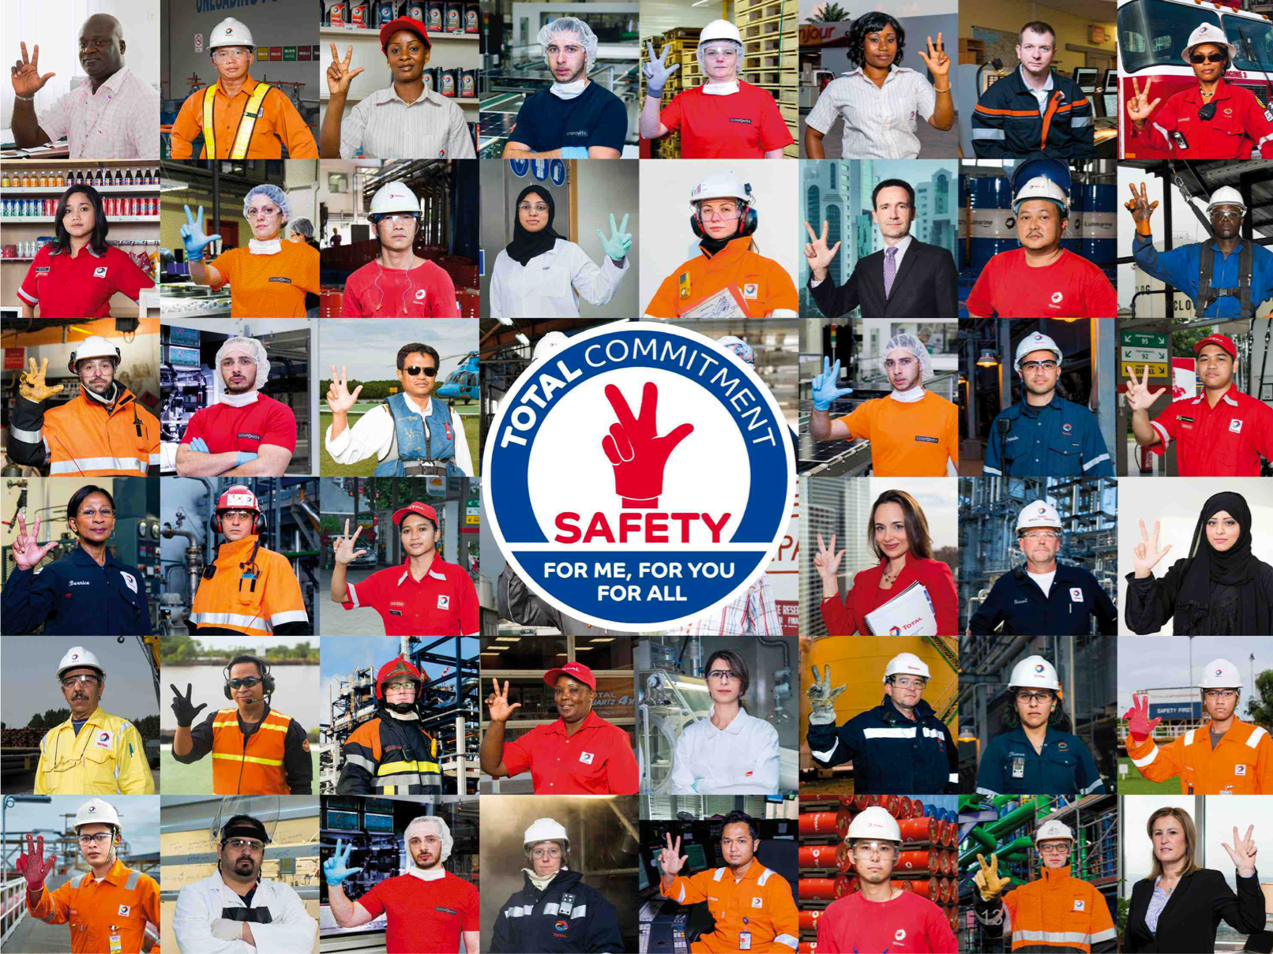
Your Safety training
Course n°3

Name:
Affiliate:
Position:

Introduction of Patrick Pouyanné
Managing Director of the Total Group

Hello dear colleagues,
Welcome to our company.
Today, you will be starting our safety training. This approach is based on shared principles of standards, norms and group requirements across all entities, sites and affiliates, wherever you are in the world.
The modules that make up the course will allow you to grasp the essence of these principles. At the end of your training, you’ll be awarded a safety Pass.
This Pass is your key to joining us as a fully-fledged member of the Total family.
I wish you every success along the way. Happy training.

What happens during these sessions?

Your course
Your course consists of modules that you will follow. You will then have to get them validated by having the trainer sign your attendance sheet.
Your course starts as of the first day of your presence within the Total Group.
Once you will have gone through all the modules in your course, a “Safety Pass” certificate will be issued to you. It proves that you have the necessary safety skills to begin your activity at Total.
Your course is described in the following pages.
The manual
You will keep this manual throughout your course, which will help you:
- validate the progression of your course,
- take notes,
- do the exercises,
- make your summary.

Timesheets
TCG 1.1
Introduction and commitment of
Top Management
Date:
Signature:
TCG 1.2
Safety as a value
Date:
Signature:
TCG 2.1
Our main HSE risks
Date:
Signature:
TCG 1.3
The HSEQ Charter
Date:
Signature:
TCG 2.2
Technological risks
Major incidents
Date:
Signature:
TCG 2.3
Safety
Deaths and accidents
Date:
Signature:
TCG 3.1
One maestro
HSE organization
Date:
Signature:
TCG 2.5b
Psychosocial risks
Date:
Signature:
TCG 4.1
Behavior
(positive and negative)
Date:
Signature:
TCG 4.2
Teamwork, manager relationships
Date:
Signature:
TCG 4.3
Relationships with contractors - exemplary conduct
Date:
Signature:
TCG 4.4
Everyone is responsible at their own level
Date:
Signature:
TCG 5.1
Golden Rules
Sanction/Recognition
Date:
Signature:
TCG 5.2
Reporting anomalies
Date:
Signature:
TCG 5.3
Feedback
Date:
Signature:
TCG 5.4
Stop Card
Date:
Signature:
TCG 7.0
Conclusions
Date:
Signature:
Timesheets
TCAS 1.0
HSE roadmap
Site/Affiliate/Entity
Date:
Signature:
TCAS 2.1
Country regulations
Date:
Signature:
TCAS 1.1
Major risks and accidents
TCAS 1.5
Psychosocial risks
Date:
Signature:
TCAS 2.5
Personal protective equipment
Date:
Signature:
TCAS 2.6
Problematic golden rules
Date:
Signature:
TCAS 2.7
Action to be taken in the event of an emergency
Date:
Signature:
TCAS 2.6
On site exercise
Application of the golden rules
Date:
Signature:
TCAS 2.7
On site exercise
Fire drill
Date:
Signature:
TCAS 3.1
Safety technical standards and associated tools
Date:
Signature:
TCAS 3.2
Affiliate HSE organization
Date:
Signature:
TCAS 3.3
Site visit
Date:
Signature:
TCAS 3.3
Workshop : Feedback of the site visit
Date:
Signature:
TCAS 4.1
Events analysis
Date:
Signature:
TCAS 4.2
Specific HSE activities
Date:
Signature:
TCAS 4.2
On site exercise on specific HSE activities
Date:
Signature:
TCAS 4.3
Experience feedback
Date:
Signature:
TCAS 4.3
On site exercise experience feedback
Date:
Signature:
TCAS 2.4
General safety rules
site/affiliate
Date:
Signature:
Date:
Signature:
Timesheets
TCT 1.1
Safety training
business specific
Date:
Signature:
TCT 2.2
Accidents related to violation of the golden rules
Date:
Signature:
TCT 2.1
Golden Rules
TCT 2.1
On site exercise golden rules
Date:
Signature:
TCT 3.1
On site exercise work permit
Date:
Signature:
TCT 3.2
Simultaneous activities
Date:
Signature:
TCT 3.3
On site exercise site visit and work permit audit
Date:
Signature:
TCT 3.3
Site Visit and Works Compliance
Date:
Signature:
TCT 3.4
Contractor management
Date:
Signature:
TCT 4.1
Human factors and weak signals
Date:
Signature:
TCT 4.2
Gestures and postures
at the workstation
Date:
Signature:
TCT 4.3
Stop Card
Date:
Signature:
TCT 4.3
On site exercise safety contact
Date:
Signature:
TCT 4.4
Audits
Date:
Signature:
TCT 4.4
On site exercise safety audit
Date:
Signature:
TCT 4.5
Improvement loop
Date:
Signature:
TCAS 4.5
On site exercise experience feedback
Date:
Signature:
TCT 3.1
Works process and work permit
Date:
Signature:
Date:
Signature:
TCT 5.1
Risk analysis
Date:
Signature:
TCT 5.3
Change Management
Date:
Signature:
TCT 5.2
Barriers
TCT 5.2
On site exercise safety barriers
Date:
Signature:
TCT 5.3
On site exercise modifications management
Date:
Signature:
Date:
Signature:
Timesheets
TCG 6.1
Fire fighting initiation
Date:
Signature:
TCG 6.2
First aid initiation
Date:
Signature:
E
-
learning
Golden Rules
Date:
Signature:
E
-
learning
Step in
Date:
Signature:
On site exercise report and individual commitments
Date:
Signature:
Practical exercise
Hunt for anomalies initiation
Date:
Signature:
Practical exercise
Visit of muster points
Date:
Signature:
Practical exercise
Discovery and use
Stop Card
Date:
Signature:

CONTENTS
Introduction of Patrick Pouyanné 2
What happens during these sessions? 3
Safety in the TOTAL Group 10
TCG 1.1: Introduction and Top Management Commitment 11
TCG 1.2: Safety as a value 12
TCG 1.3: The HSEQ Charter 13
TCG 2.2: Technological risks and major incidents 15
TCG 2.3: Safety: Deaths and accidents 16
TCG 2.5b: Psychosocial Risks 17
TCG 3.1: Maestro – HSE Organization 18
TCG 4.1: Behaviors (positive and negative) 19
TCG 4.2: Teamwork and manager relationships 21
TCG 4.3: Relationships with contractors - exemplary conduct 22
TCG 4.4: Everyone is responsible at their own level 23
TCG 5.1: The Golden Rules 24
TCG 5.2: Anomaly reporting 25
TCG 5.3: Feedback 27
TCG 5.4: Stop Card 28
TCG 6.1: Fire fighting initiation 29
TCG 6.2: First aid initiation 30
TCG 7.0: Conclusion and commitments 31
Summary 32
Safety in my affiliate 33
TCAS 1.0: My affiliate’s HSE roadmap 34
TCAS 1.1: My affiliate’s major risks and incidents 35
TCAS 1.5: My affiliate’s psychosocial risks 36
TCAS 2.1: Country regulations 37
TCAS 2.4: My affiliate’s general safety rules 38
TCAS 2.5: Personal protective equipment 39
TCAS 2.6: Problematic golden rules 40
TCAS 2.6: On site exercise on the application of the golden rules 41
TCAS 2.7: Action to be taken in the event of an emergency 42
TCAS 2.7: Fire drill on site exercise 43
TCAS 3.1: Safety technical standards and associated tools 44
TCAS 3.2: Affiliate HSE organization 45
TCAS 3.3: Site visit 46
TCAS 3.3: Workshop : Feedback of the site visit 47
TCAS 4.1: Events analysis 48
TCAS 4.2: Specific HSE activities 49
TCAS 4.2: On site exercise on specific HSE activities 50
TCAS 4.3: Experience feedback 51
TCAS 4.3: On site exercise experience feedback 52
TCT 1.1: Activity specific safety 53
TCT 2.1: Golden Rules 54
TCT 2.1: On site exercise golden rules 55
TCT 2.2: Top 5 Accidents Linked to Violation of the Golden Rules 56
TCT 3.1: Works process and work permit 57
TCT 3.1: On site exercise work permit workflow 58
TCT 3.2: Simultaneous activities 59
TCT 3.3: Site Visit and Works Compliance 60
TCT 3.3: On site exercise site visit and work permit audit 61
TCT 3.4: Contractor management 62
TCT 4.1: Human factors and weak signals 63
TCT 4.4: Audit 64
TCT 4.4: On site exercise safety audit 65
TCT 4.5: Improvement loop 66
TCT 4.5: On site exercise using experience feedback 67
TCT 5.1: Risk analysis 68
TCT 5.2: Barriers 69
TCT 5.2: On site exercise safety barriers 70
TCT 5.3: Change Management 71
TCT 5.3: On site exercise modifications 72
Safety at my workstation 73
TCT 4.2: Gestures and postures 74
TCT 4.3: Stop card 75
TCT 4.3: On site exercise safety contact 76
Discovery report - Stop card 77
Conclusion/Commitments 79
Conclusion of my course 80
My commitments 81

Safety in the TOTAL Group

TCG 1.1: Introduction and Top Management Commitment

What do you think are this video’s keywords and key ideas?

What stands out or surprises you the most in what Patrick Pouyanné says?

How could one summarize his commitment with respect to Safety?

TCG 1.2: Safety as a value

TCG 1.3: The HSEQ Charter

TCG 2.1: Our main safety risks

Exercise: TRIR calculation
Exercise 1 – Calculate your TRIR
Over the course of your career, assuming that you commit one infraction during it.
A career lasts on average 40 years, at a rate of 40 hours worked per week and 50 weeks per year.
Exercise 2 – Calculate the TRIR of a company
A company of 1000 employees counts 1 accident over one year (40 hours worked per week, and 50 weeks per annum).
Exercise 3
A company of 100,000 employees has 50 accidents per year (40 hours worked per week and 50 weeks per year).

TCG 2.2: Technological risks and major incidents

Exercise: Which consequences?
From this list, what do you think the consequences (on people, facilities, the company and neighbors) will be?
Accident | Consequences?
Oil slick
A car leaves the road and flips over 4 times
A person falls off a scaffold
Gas pipeline explosion
Fire in a storage tank
Falling down a staircase

TCG 2.3: Safety: Deaths and accidents

TCG 2.5b: Psychosocial Risks

TCG 3.1: Maestro – HSE Organization

Exercise: Which are the responsibilities of:
- John:

- The center manager:

- The instructor:

- Of each skydiver:

- An HSE technician, if John recruited one:

TCG 4.1: Behaviors (positive and negative)

Exercise: behavior or not?
- Working at height without a harness
- Being stressed
- Taking a Safety Tour
- Suggesting one of your colleagues take a Safety Tour
- Convincing yourself that safety is your priority
- Driving the wrong way on the highway

Exercise: error or fault?
- Speeding on-site
- Forgetting a big step in a procedure
- Bringing alcohol on-site
- Not understanding a plan or procedure
- Not using the PPE provided
- Confusing two chemical products
- Driving a site machine without wearing a seat belt
- Using a phone while driving
- Opening a different valve to the one indicated in the procedure because you don't think it is the right one

TCG 4.2: Teamwork and manager relationships

TCG 4.3: Relationships with contractors - exemplary conduct

Exercise: List everyone's safety actions and their differences
Operators:
- Site coordinator (Emile)

- Large construction company for major work

- Local craftsmen for joinery work

TCG 4.4: Everyone is responsible at their own level

TCG 5.1: The Golden Rules

TCG 5.2: Anomaly reporting

Exercise: finding anomalies

What anomalies did you identify?

In relation to these anomalies, what could have been done to prevent this accident?

TCG 5.3: Feedback

TCG 5.4: Stop Card

TCG 6.1: Fire fighting initiation

TCG 6.2: First aid initiation

TCG 7.0: Conclusion and commitments

- Which actions would you like to implement in your future position to help reinforce the safety value?

- Which difficulties do you anticipate?

- Do you have any ideas yet on how to cope with these difficulties?

Summary

Safety in my affiliate

TCAS 1.0: My affiliate’s HSE roadmap

TCAS 1.1: My affiliate’s major risks and incidents

TCAS 1.5: My affiliate’s psychosocial risks

TCAS 2.1: Country regulations

TCAS 2.4: My affiliate’s general safety rules

TCAS 2.5: Personal protective equipment

TCAS 2.6: Problematic golden rules

TCAS 2.6: On site exercise on the application of the golden rules

TCAS 2.7: Action to be taken in the event of an emergency

TCAS 2.7: Fire drill on site exercise

TCAS 3.1: Safety technical standards and associated tools

TCAS 3.2: Affiliate HSE organization

TCAS 3.3: Site visit

TCAS 3.3: Workshop : Feedback of the site visit

TCAS 4.1: Events analysis

TCAS 4.2: Specific HSE activities

TCAS 4.2: On site exercise on specific HSE activities

- What surprised you the most when you took part in the event?

- What were the strong point(s) that surprised you most?

- What were the most unexpected weak points(s) for you? What are your suggestions for improving these weaknesses?

TCAS 4.3: Experience feedback

TCAS 4.3: On site exercise experience feedback

TCT 1.1: Activity specific safety

TCT 2.1: Golden Rules

TCT 2.1: On site exercise golden rules

TCT 2.2: Top 5 Accidents Linked to Violation of the Golden Rules

TCT 3.1: Works process and work permit

TCT 3.1: On site exercise work permit workflow

TCT 3.2: Simultaneous activities

TCT 3.3: Site Visit and Works Compliance

TCT 3.3: On site exercise site visit and work permit audit

TCT 3.4: Contractor management

TCT 4.1: Human factors and weak signals

TCT 4.4: Audit

TCT 4.4: On site exercise safety audit

TCT 4.5: Improvement loop

TCT 4.5: On site exercise using experience feedback

TCT 5.1: Risk analysis

TCT 5.2: Barriers

TCT 5.2: On site exercise safety barriers

TCT 5.3: Change Management

TCT 5.3: On site exercise modifications

Safety at my workstation

TCT 4.2: Gestures and postures

TCT 4.3: Stop card

TCT 4.3: On site exercise safety contact

Discovery report - Stop card

Under which circumstances have you intervened with the Stop Card?

How did people react?

What surprised you the most?

What did you learn from your intervention? And from the use of the Stop Card in general?

Conclusion/Commitments

Conclusion of my course

My commitments
Fill out this page only when your instructor asks you to.
Safety...
For me:

For you:

For everyone:

