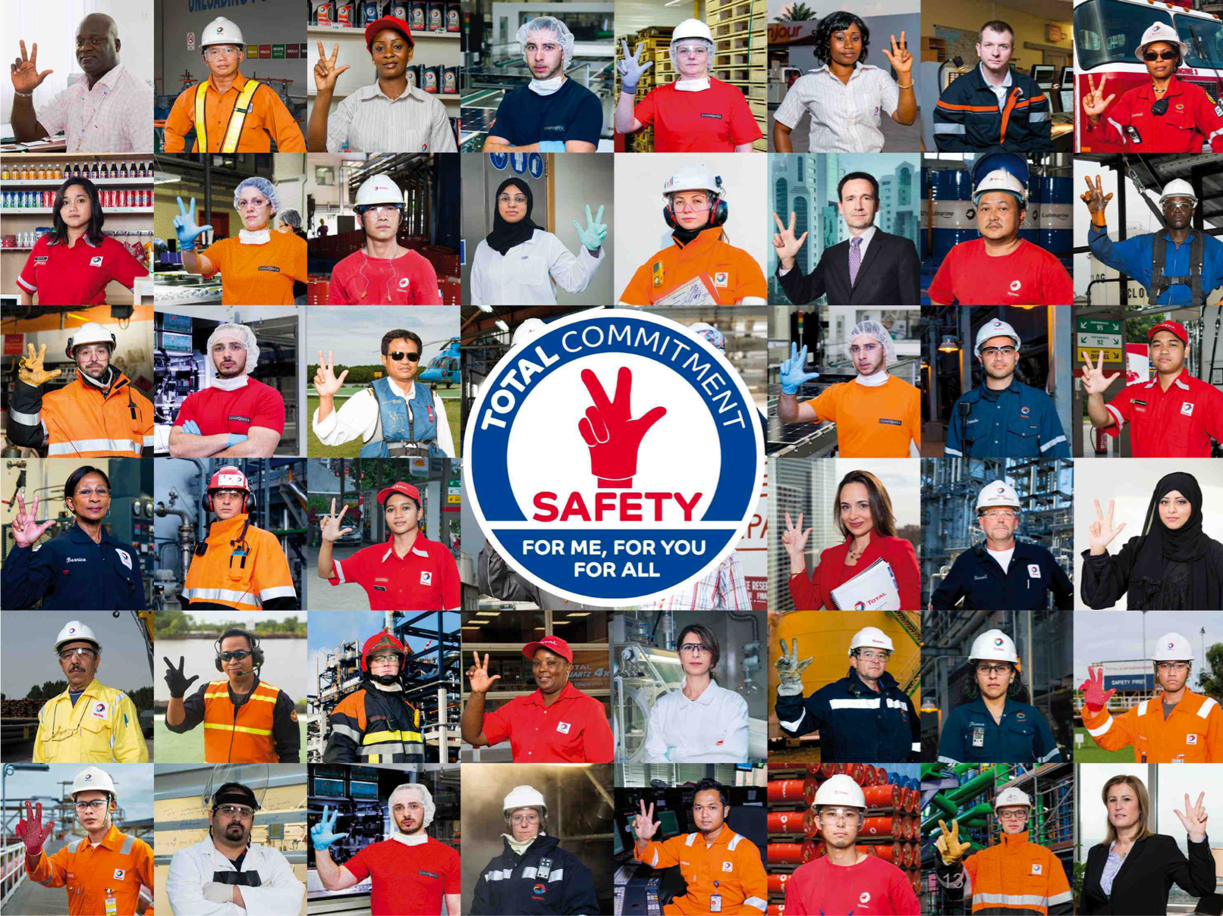
Your Safety training
Course n°4

Name:
Affiliate:
Position:

Introduction of Patrick Pouyanné
Managing Director of the Total Group

Hello dear colleagues,
Welcome to our company.
Today, you will be starting our safety training. This approach is based on shared principles of standards, norms and group requirements across all entities, sites and affiliates, wherever you are in the world.
The modules that make up the course will allow you to grasp the essence of these principles. At the end of your training, you’ll be awarded a safety Pass.
This Pass is your key to joining us as a fully-fledged member of the Total family.
I wish you every success along the way. Happy training.

What happens during these sessions?

Your course
Your course consists of modules that you will follow. You will then have to get them validated by having the trainer sign your attendance sheet.
Your course starts as of the first day of your presence within the Total Group.
Once you will have gone through all the modules in your course, a “Safety Pass” certificate will be issued to you. It proves that you have the necessary safety skills to begin your activity at Total.
Your course is described in the following pages.
The manual
You will keep this manual throughout your course, which will help you:
- validate the progression of your course,
- take notes,
- do the exercises,
- make your summary.

Timesheets
TCG 1.1
Introduction and commitment of Top Management
Date:
Signature:
TCG 1.2
Safety as a value
Date:
Signature:
TCG 2.1
Our main HSE risks
Date:
Signature:
TCG 1.3
The HSEQ charter
Date:
Signature:
TCG 2.3
Safety
Deaths and accidents
Date:
Signature:
TCG 2.5b
Psychosocial risks
Date:
Signature:
TCG 4.1
Behavior
(positive and negative)
Date:
Signature:
TCG 4.2
Teamwork, manager relationships
Date:
Signature:
TCG 4.4
Everyone is responsible at their own level
Date:
Signature:
TCG 5.1
Golden Rules
Sanction/Recognition
Date:
Signature:
TCG 5.2
Reporting anomalies
Date:
Signature:
TCG 5.3
Feedback
Date:
Signature:
TCG 5.4
Stop Card
Date:
Signature:
TCG 7.0
Conclusions
Date:
Signature:
Timesheets
TCAS 1.0
HSE roadmap
Site/affiliate
Date:
Signature:
TCAS 1.1
Major risks and accidents
TCAS 2.5
Personal protective equipment
Date:
Signature:
TCAS 2.6
Problematic golden rules
Date:
Signature:
TCAS 2.7
Action to be taken in the event
of an emergency
Date:
Signature:
TCAS 2.6
On site exercise
Application of the golden rules
Date:
Signature:
TCAS 2.7
On site exercise :
mustering
Date:
Signature:
TCAS 3.1
Safety technical standards and
associated tools
Date:
Signature:
TCAS 3.2
Affiliate HSE organization
Date:
Signature:
TCAS 3.3
Site visit
Date:
Signature:
TCAS 3.3
Workshop: Feedback of the site visit
Date:
Signature:
TCAS 2.4
General safety rules
site/affiliate
Date:
Signature:
Date:
Signature:
Timesheets
TCG 5.4
On site exercise Stop card
Signature:
Date:
TCG 6.1
Fire fighting initiation
Date:
Signature:
TCG 6.2
First aid initiation
Date:
Signature:
E-learning
Golden Rules
Date:
Signature:
E-learning
Step in
Date:
Signature:
Discovery report and individual commitments
Date:
Signature:
Practical exercise
Hunt for anomalies initiation
Date:
Signature:
Practical exercise
Visit of muster points
Date:
Signature:
Practical exercise
Discovery and use
Stop Card
Date:
Signature:

CONTENTS
Introduction of Patrick Pouyanné 2
What happens during these sessions? 3
Safety in the TOTAL Group 8
TCG 1.1: Introduction and Top Management Commitment 9
TCG 1.2: Safety as a value 10
TCG 1.3: The HSEQ Charter 11
TCG 2.1: Our main HSE risks 13
TCG 2.3: Safety: Deaths and accidents 14
TCG 2.5b: Psychosocial Risks 15
TCG 4.1: Behaviors (positive and negative) 16
TCG 4.2: Teamwork and manager relationships 18
TCG 4.4: Everyone is responsible at their own level 19
TCG 5.1: The Golden Rules 20
TCG 5.2: Anomaly reporting 21
TCG 5.3: Feedback 23
TCG 5.4: Stop Card 24
TCG 7.0: Conclusion and commitments 25
Summary 26
Safety in my affiliate 27
TCAS 1.0: My affiliate’s HSE roadmap 28
TCAS 1.1: My affiliate’s major risks and incidents 29
TCAS 2.4: My affiliate’s general safety rules 30
TCAS 2.5: Personal protective equipment 31
TCAS 2.6: Problematic golden rules 32
TCAS 2.6: On site exercise on the application of the golden rules 33
TCAS 2.7: Action to be taken in the event of an emergency 34
TCAS 3.1: Safety technical standards and associated tools 35
TCAS 3.2: Affiliate HSE organization 36
TCAS 3.3: Site visit 37
TCAS 3.3: Workshop: Feedback of the site visit 38
Safety at my workstation 39
TCG 6.1: Fire fighting initiation 40
TCG 6.2: First aid initiation 41
TCG 5.4: On site exercise stop card 42
TCG 5.4: Discovery report - Stop card 43
TCAS 2.7: On site exercise: mustering 45
Conclusion/Commitments 46
Conclusion of my course 47
My commitments 48

Safety in the TOTAL Group

TCG 1.1: Introduction and Top Management Commitment

What do you think are this video’s keywords and key ideas?

What stands out or surprises you the most in what Patrick Pouyanné says?

How could one summarize his commitment with respect to Safety?

TCG 1.2: Safety as a value

TCG 1.3: The HSEQ Charter

TCG 2.1: Our main safety risks

Exercise: TRIR calculation
Exercise 1 – Calculate your TRIR
Over the course of your career, assuming that you commit one infraction during it.
A career lasts on average 40 years, at a rate of 40 hours worked per week and 50 weeks per year.
Exercise 2 – Calculate the TRIR of a company
A company of 1000 employees counts 1 accident over one year (40 hours worked per week, and 50 weeks per annum).
Exercise 3
A company of 100,000 employees has 50 accidents per year (40 hours worked per week and 50 weeks per year).

TCG 2.1: Our main HSE risks

TCG 2.3: Safety: Deaths and accidents

TCG 2.5b: Psychosocial Risks

TCG 4.1: Behaviors (positive and negative)

Exercise: behavior or not?
- Working at height without a harness
- Being stressed
- Taking a Safety Tour
- Suggesting one of your colleagues take a Safety Tour
- Convincing yourself that safety is your priority
- Driving the wrong way on the highway

Exercise: error or fault?
- Speeding on-site
- Forgetting a big step in a procedure
- Bringing alcohol on-site
- Not understanding a plan or procedure
- Not using the PPE provided
- Confusing two chemical products
- Driving a site machine without wearing a seat belt
- Using a phone while driving
- Opening a different valve to the one indicated in the procedure because you don't think it is the right one

TCG 4.2: Teamwork and manager relationships

TCG 4.4: Everyone is responsible at their own level

TCG 5.1: The Golden Rules

TCG 5.2: Anomaly reporting

Exercise: finding anomalies

What anomalies did you identify?

In relation to these anomalies, what could have been done to prevent this accident?

TCG 5.3: Feedback

TCG 5.4: Stop Card

TCG 7.0: Conclusion and commitments

- Which actions would you like to implement in your future position to help reinforce the safety value?

- Which difficulties do you anticipate?

- Do you have any ideas yet on how to cope with these difficulties?

Summary

Safety in my affiliate

TCAS 1.0: My affiliate’s HSE roadmap

TCAS 1.1: My affiliate’s major risks and incidents

TCAS 2.4: My affiliate’s general safety rules

TCAS 2.5: Personal protective equipment

TCAS 2.6: Problematic golden rules

TCAS 2.6: On site exercise on the application of the golden rules

TCAS 2.7: Action to be taken in the event of an emergency

TCAS 3.1: Safety technical standards and associated tools

TCAS 3.2: Affiliate HSE organization

TCAS 3.3: Site visit

TCAS 3.3: Workshop: Feedback of the site visit

Safety at my workstation

TCG 6.1: Fire fighting initiation

TCG 6.2: First aid initiation

TCG 5.4: On site exercise stop card

TCG 5.4: Discovery report - Stop card

Under which circumstances have you intervened with the Stop Card?

How did people react?

What surprised you the most?

What did you learn from your intervention? And from the use of the Stop Card in general?

TCAS 2.7: On site exercise: mustering

Conclusion/Commitments

Conclusion of my course

My commitments
Fill out this page only when your instructor asks you to.
Safety…
For me:

For you:

For everyone:

